
Emergency Alert System (EAS) Plan for the State of Michigan

Table of Contents
I. Intent and Purpose of the Plan 6
II. How This Plan Was Developed 7
III. Authority 8
IV. Roles of the Communication Committees 9
A. State Emergency Communications Committee 9
B. Local Emergency Communications Committee 9-10
V. General Considerations 10
VI. National, State and Local EAS: Participation and Priorities 11
A. National EAS Participation 11
B. State EAS Participation 11
C. Local EAS Participation 11
D. Program Control 11
E. Rebroadcast Authority 11
F. Liability 12
G. EAS Priorities 12
H. 800 MHz Radio System 12
VII. Definitions and Concepts 13
A. Definitions 13
B. Delivery 14
C. EMnet 15
VIII. Origins of EAS Information 16
A. National Level System 16
1. National-Level Event Codes 16
B. State Level System 16
2. State-Level Event Codes 17
C. Local Level System 17
3. Local-level Event Codes and Priorities 18-21
D. EAS Message Priorities………………………………………………………………….21
IX. Required EAS Testing 22
A. Required Monthly Test (RMT) 22
1. Recommended Test Times 22-23
2. Reception and Retransmission of the RMT 23
3. Required Weekly Test (RWT) 23
X. EAS Equipment and Operations Guidelines 24
A. Programming Your Encoder/Decoder Unit 24
1. Modes of Operation 24
2. Manual Operation 24
3. Automatic Operation 24
4. Semi-Automatic Operation 25
5. Unattended Operation 25
6. County Location Codes 25
7. CAP Compliance 25
B. Guidance for Originators of EAS Messages 26
1. Law Enforcement 26
2. National Weather Service (NWS) 26
3. Nuclear 27
Appendix A: Members of SECC and LECC Chairmen 28
Appendix A-1: Members of SECC 28-29
Appendix A-2: SECC EAS Member Chairmen 29
Appendix B: Officials Designated to Activate EAS 30
Appendix C: State Local Primary Stations 31-32
Appendix D: Monitoring Charts by Areas 33
Appendix D-1: Southeastern 33
Appendix D-2: Southwestern 33
Appendix D-3: South Central 33
Appendix D-4: Washtenaw-Lenawee 33
Appendix D-5: Western 33
Appendix D-6: West Central 33
Appendix D-7: Northwestern 34
Appendix D-8: Central 34
Appendix D-9: East Central 34
Appendix D-10: Northeastern 34
Appendix D-11: Upper Peninsula – Eastern 34
Appendix D-12: Upper Peninsula – Central 34
Appendix D-13: Upper Peninsula – Western 34
Appendix D-14: Upper Peninsula – Northwestern 35
APPENDIX D-15: LOCAL PRIMARY STAION'S MONITORING CHART………………………..35
APPENDIX D-16: sTATE MONITORING ASSIGNMENT FOR ALL STATIONS…………….36-44
Appendix E: Authentication Procedures 45
Appendix E-1: State Police 45
Appendix E-2: National Oceanic and Atmospheric Administration (NOAA) 45
Appendix E-3: County 45
Appendix E-4: Local 45
Appendix F: Scripts 46
Appendix F-1: Required Monthly Test – Local/State Origination Script 46-47
Appendix F-2: Local Activation Procedure 48
Appendix F-3: State Activation 49
Appendix G: List of Federal Information Processing Standards (FIPS) Codes 50-51
Appendix H: List of Federally Mandated Event Codes 52-53
*Minimum required codes 53
Appendix I: Michigan FIPS Codes 54-55
Appendix J: Standard Operational Tests 56
Appendix K: EAS Message Protocol Overview 57
Appendix K-1: Message Protocol Explanation 57
1. The Preamble and EAS Header 57-58
2. Audio Attention Signal 59
3. EAS Message Text 59
4. End-of-Message Code 59
5. Jurisdiction 60
Appendix L: Michigan Collaborating Operating Group (COG) Information 61
Appendix M: State Police Districts/EAS Area Maps … …………62.
Appendix M-1: State Police 63
Appendix M-2: EAS Areas 64
Appendix N: List of EAS Local Areas 64
Appendix N-1: Southeastern 65
Appendix N-2: Southwestern 65
Appendix N-3: South Central 65
Appendix N-4: Washtenaw-Lenawee 65
Appendix N-5: Western 65
Appendix N-6: West Central 66
Appendix N-7: Northwestern 66
Appendix N-8: Central 66
Appendix N-9: East Central 66
Appendix N-10: Northeastern 67
Appendix N-11: Upper Peninsula – Eastern 67
Appendix N-12: Upper Peninsula – Central 67
Appendix N-13: Upper Peninsula – Western 67
Appendix N-14: Upper Peninsula – Northwestern 67
Appendix O: Local EAS District Plans 68
Appendix O-1: Southeastern 68
Appendix O-2: Southwestern 68
Appendix O-3: South Central 68
Appendix O-4: Washtenaw-Lenawee 68
Appendix O-5: Western 68
Appendix O-6: West Central 68
Appendix O-7: Northwestern 68
Appendix O-8: Central 68
Appendix O-9: East Central 68
Appendix O-10: Northeastern 68
Appendix O-11: Upper Peninsula – Eastern 68
Appendix O-12: Upper Peninsula – Central 68
Appendix O-13: Upper Peninsula – Western 68
Appendix O-14: Upper Peninsula - Northwestern 68
Appendix P: Record of Distribution 69
Appendix Q: Record of change 69
Appendix r: promulgation page……………………………………………………………….......70-71

I. Intent and Purpose of the Plan

The State of Michigan Emergency Alert System (EAS) Plan delineates responsibilities and establishes procedures for Michigan broadcasters, cable television operators and state and local entities authorized to use the EAS in Michigan. The plan provides guidelines on alerting the public through the dissemination of information during national, state and local emergencies. The plan also provides provisions for continued communications services during emergencies and technical information required to perform the required procedures and responsibilities.

The EAS Plan is mandated by the Federal Communications Commission (FCC). This Plan is an adjunct to the FCC EAS Rules, and is not meant to be a summary, in whole or in part, of those rules. Consult the FCC Rules Part 11 for complete rules information regarding the EAS. (47 C.F.R. Part 11)

II. How This Plan Was Developed

This plan was prepared by the Michigan State Emergency Communications Committee (SECC) which consists of representatives from the following organizations:

- Michigan Association of Broadcasters (MAB)
- Michigan State Police, Emergency Management and Homeland Security Division (MSP/EMHSD)
- National Weather Service (NWS)
- Federal Communications Commission (FCC)
- Federal Emergency Management Agency (FEMA)
- Michigan Emergency Management Association (MEMA)
- Members of Michigan Cable Companies
- Michigan Coalition for the Deaf and Hard of Hearing

III. Authority

Title 47 U.S.C. 151, 154 (i) and (o),303 (r),544 (g) 606; and 47 C.F.R. Part 11, FCC Rules and Regulations, Emergency Alert System (EAS) as pertains to day-to-day emergency operations.

Michigan Emergency Management Act, 30.410(a) (Act 390 of 1976, as amended).

IV. Roles of the Communication Committees

The State Emergency Communications Committee (SECC) and Local Emergency Communications Committee (LECC) are responsible for developing and finalizing plans for their respective jurisdiction. These committees provide state and local leadership for EAS operations in Michigan.

State Emergency Communications Committee

The purpose of the SECC is to oversee the implementation of state emergency communications plans at the state and local levels. The SECC is chaired by a Michigan broadcast industry representative appointed by the FCC.

The SECC:

- Develops emergency communications plans that comply with FCC EAS rules
- Develops authentication procedures for activating state emergency communications plans
- Provides assistance to the broadcast and cable industries in developing emergency communications plans
- Maintains liaisons with businesses, organizations and public service entities in the state that require emergency communications
- Encourages research to improve the overall effectiveness of emergency communications within the state of Michigan
- Provides technical advice to state and local authorities and private organizations within the state concerning emergency communications

See Appendix A for current members of the SECC.

Local Emergency Communications Committee

The LECC serves one EAS Area with its primary purpose being to prepare and maintain a viable EAS Plan for that area. The LECC brings together key people necessary to provide successful communications to support warnings and emergency information for the public.

The LECC is comprised of:

- Representatives from local stations
- Cable and Broadband providers
- Michigan Association of Broadcasters
- Local emergency management authorities
- MSP/EMHSD District Coordinators
- Representative of special needs populations
- Other members as deemed appropriate by the committee

MSP/EMHSD District Coordinators are responsible for coordinating the state response to emergencies within a state designated geographical region.

Some MSP/EMHSD Districts do not coincide exactly with the EAS Areas, which are based on broadcast markets. Therefore, a MSP/EMHSD District Coordinator may be responsible for whole or parts of an EAS Area, or parts of more than one EAS Area. Two MSP/EMHSD District Coordinators may serve portions of a single EAS Area. See Appendix M for a map showing MSP Districts. See Appendix M-2 of this plan for a map showing EAS Areas.

Each LECC shall elect a chairman or have a chairman appointed based on a recommendation by the SECC. The chairman in turn appoints the vice-chair(s). Larger committees having multiple stations may consider having a separate vice-chair for Cable, AM, FM and TV stations, or combinations thereof.

V. General Considerations

A Word of Caution: The emergency management community has a tool for direct access to all area broadcasters, cable operators and with proper authorization, cell phone providers and National Weather Service, to disseminate information. These warning distribution providers expect the EAS to be used only for life-threatening emergencies.

Please keep in mind:

- First, some broadcasters and most cable operators will have their EAS decoders set to Automatic Mode. There may be no one at these stations to screen a message and to decide if it should be aired. The broadcasters are depending on an EAS alert being sent for only a life-threatening emergency. If the EAS is triggered for a non-life-threatening event, the confidence of the warning distribution providers may be lost.
- Second, all broadcast stations and cable systems are required to transmit national and state emergency messages; however, they participate in the local level EAS on a voluntary basis. Other than Local Primary stations, they are not required to carry local EAS Alerts. They may choose an alternate response, short of EAS activation or choose not to respond.

Emergency services personnel, warning distribution providers should always strive to maintain a good working relationship to provide assistance to their communities in times of emergency.

VI. National, State and Local EAS: Participation and Priorities

The State of Michigan is divided into 14 EAS Areas based on commonly defined broadcast markets. The EAS Areas and the counties they serve are listed in Appendix N.

National EAS Participation
All broadcasters and subject cable operators are required to participate in the national-level EAS. All stations and cable systems will carry Presidential messages and will continue on the air for additional messages from the federal or state level.

All broadcasters and cable operators must transmit a Required Weekly Test (RWT) on random days and times and once a month and must re-transmit the Required Monthly Test (RMT) within 60 minutes of receiving it on their EAS decoder. These actions are required of all broadcasters and cable operators.

State EAS Participation

All EAS activations from the Governor or his/her designee must be carried by all broadcast stations and cable systems.

Local EAS Participation

Participation in the Local Area EAS is voluntary and is encouraged for all broadcasters and cable operators. Broadcast stations and cable operators electing to participate in the Local Area EAS must follow the procedures found in this EAS Plan.

Program Control

Participation in this EAS Plan shall not be deemed as a relinquishment of program control nor prohibit a broadcast licensee from exercising their independent discretion and responsibility in any given situation.

Rebroadcast Authority

Broadcast stations and cable systems transmitting EAS emergency communications shall be deemed to have conferred rebroadcast authority. Management of each broadcast station and cable system may exercise discretion regarding the broadcast of emergency information and instructions to the general public.

This authority is provided by FCC Rules and Regulations [11.54d].

Liability

Notwithstanding good-faith intentions to carry Local EAS alerts, due to the voluntary nature of the EAS at the local level, no owner, management or personnel at any Michigan broadcast station, cable system, or state broadcast network may be held liable by any person or entity for the failure to transmit any particular EAS alert, whether that failure is intentional or unintentional, and regardless of the effect that failure has on any person or entity.

State Primary (SP), State Relay (SR) and Local Primary (LP-1, LP-1) stations in particular, which agree by accepting the EAS Designation to monitor additional EAS sources and to re-transmit certain EAS alerts, are merely demonstrating their intentions to perform these additional duties, not guaranteeing their performance.

EAS Priorities

EAS Priorities set forth in the FCC rules [11.44] are as follows:

1) National EAS Messages
2) Local EAS Messages
3) State EAS Messages
4) Messages from the National Information Center (NIC)

800 MHz Radio System

The Michigan Public Safety Communication System (MPSCS) extends throughout the state and is used for interoperable communications by the Michigan State Police (MSP) and other government users. MPSCS allows the use of the 800 MHz Radio System (800 MHz) as a backup for emergency communications to the Local Primary Stations (LP) from state and local emergency management authorities and the National Weather Service.

The Local Primary Stations are the broadcast stations designated as the primary and secondary distribution points for emergency messages for the EAS Area. These stations are referred to in this plan as LP-1 and LP-2 for each EAS Area. An EAS Area may contain more than two Local Primary Stations. Each LP-1 and LP-2 has been provided with one 800 MHz radio.

The Local Primary Stations are required to keep the radio in an easily accessible location, within hearing range of station personnel at all times and in good working condition. The radios have been programmed and provided to each LP-1 and LP-2 by the MSP at no cost to the station. Should the radio malfunction or expire at no fault of the station, it will be repaired or replaced at no cost to the station. If the radio is damaged at the fault of the LP-1 or LP-2, that station will bear costs to repair the radio.

Contact your local emergency management authority or Michigan State Police District Coordinator for information on the testing schedule and procedures for 800 MHz radios in your area. Participating members of the EAS system who are in possession of an 800 MHZ radio are required to participate in their local radio testing program.

VII. Definitions and Concepts

Definitions

Table 1: Definitions
Term | Definition
Emergency | A situation posing an extraordinary threat to the safety of life and property. Examples are natural situations such as: tornadoes, flash floods, severe winter conditions, extremely heavy snows or widespread fires and man-made situations such as: discharge of toxic gases, widespread power failures, industrial explosions, civil disorders and nuclear incidents.
EAS Designation | EAS designations were created by the FCC and identify the EAS status of every broadcaster and cable operator.
Local Primary (LP) | Key stations are identified in each of the State’s EAS Areas with at least two in each area. The LP-1 is the main Local Primary station, with the LP-2 as the alternate. LP-1 and LP-2 stations are monitored by most other stations in the area. In some instances, several stations may monitor a designated LP-3, LP-4 or LP-5 instead of a LP1 or LP-2 due to local reception conditions.
Michigan Intelligence Operations Center (MIOC) | The operations center of the Michigan State Police is housed in the MIOC. The MIOC is the origination point of Amber Alerts and may issue messages from the Governor or other officials authorized to issue a state emergency alert. In certain emergency situations, upon request of an individual county authority, the MIOC may also issue an EAS warning for that county.
Non-Participating for Local (NL) | Each operational area will be encouraged to develop priority designations for anticipated local emergency contingencies. Each station and cable system will be responsible for deciding what types of emergency alerts will be aired and under what circumstances they will program their EAS encoder/decoder to automatically relay emergency alert notifications.
Participating National (PN) | Stations that participate in forwarding national-level emergency messages have this designation. This includes all entities subject to FCC rules part 11. PNs monitor the area LP stations and deliver EAS alerts directly to the general public in case of a national level emergency.
Primary Entry Point (PEP) Station | The delivery mechanism for national EAS live presidential messages to the public. This station will be received and distributed by the State Primary station and State Relay entities for disseminating national emergency messages.
State Emergency Operations Center (SEOC) | The SEOC is responsible for coordinating the state’s resources in response to emergencies. The SEOC may be the origination point of messages from the Governor or other officials specifically authorized to issue a state emergency alert.
State Primary (SP) | A state primary station (SP) serves as the originating station for all state level EAS alerts, as well as the distribution point for all national level EAS alerts.
State Relay (SR) | State Relay (SR) stations monitor the State Primary Station and will relay national or state emergency messages from the President or Governor to local areas. Local primary stations will monitor at least one or more State Primary or State Relay sources.

Dual Delivery System

The goal of Michigan’s EAS is a fully automated system that allows emergency managers to provide citizens quickly with vital information. The system forwards messages via over-the-air broadcasting using primary stations selected for optimal signal coverage. This process has been altered to overcome geographical obstacles in Michigan by using a dual satellite and Internet based system complementing the existing analog based EAS system. The following figure depicts the information paths of an EAS message:

Figure 1: Current Michigan EAS Delivery System
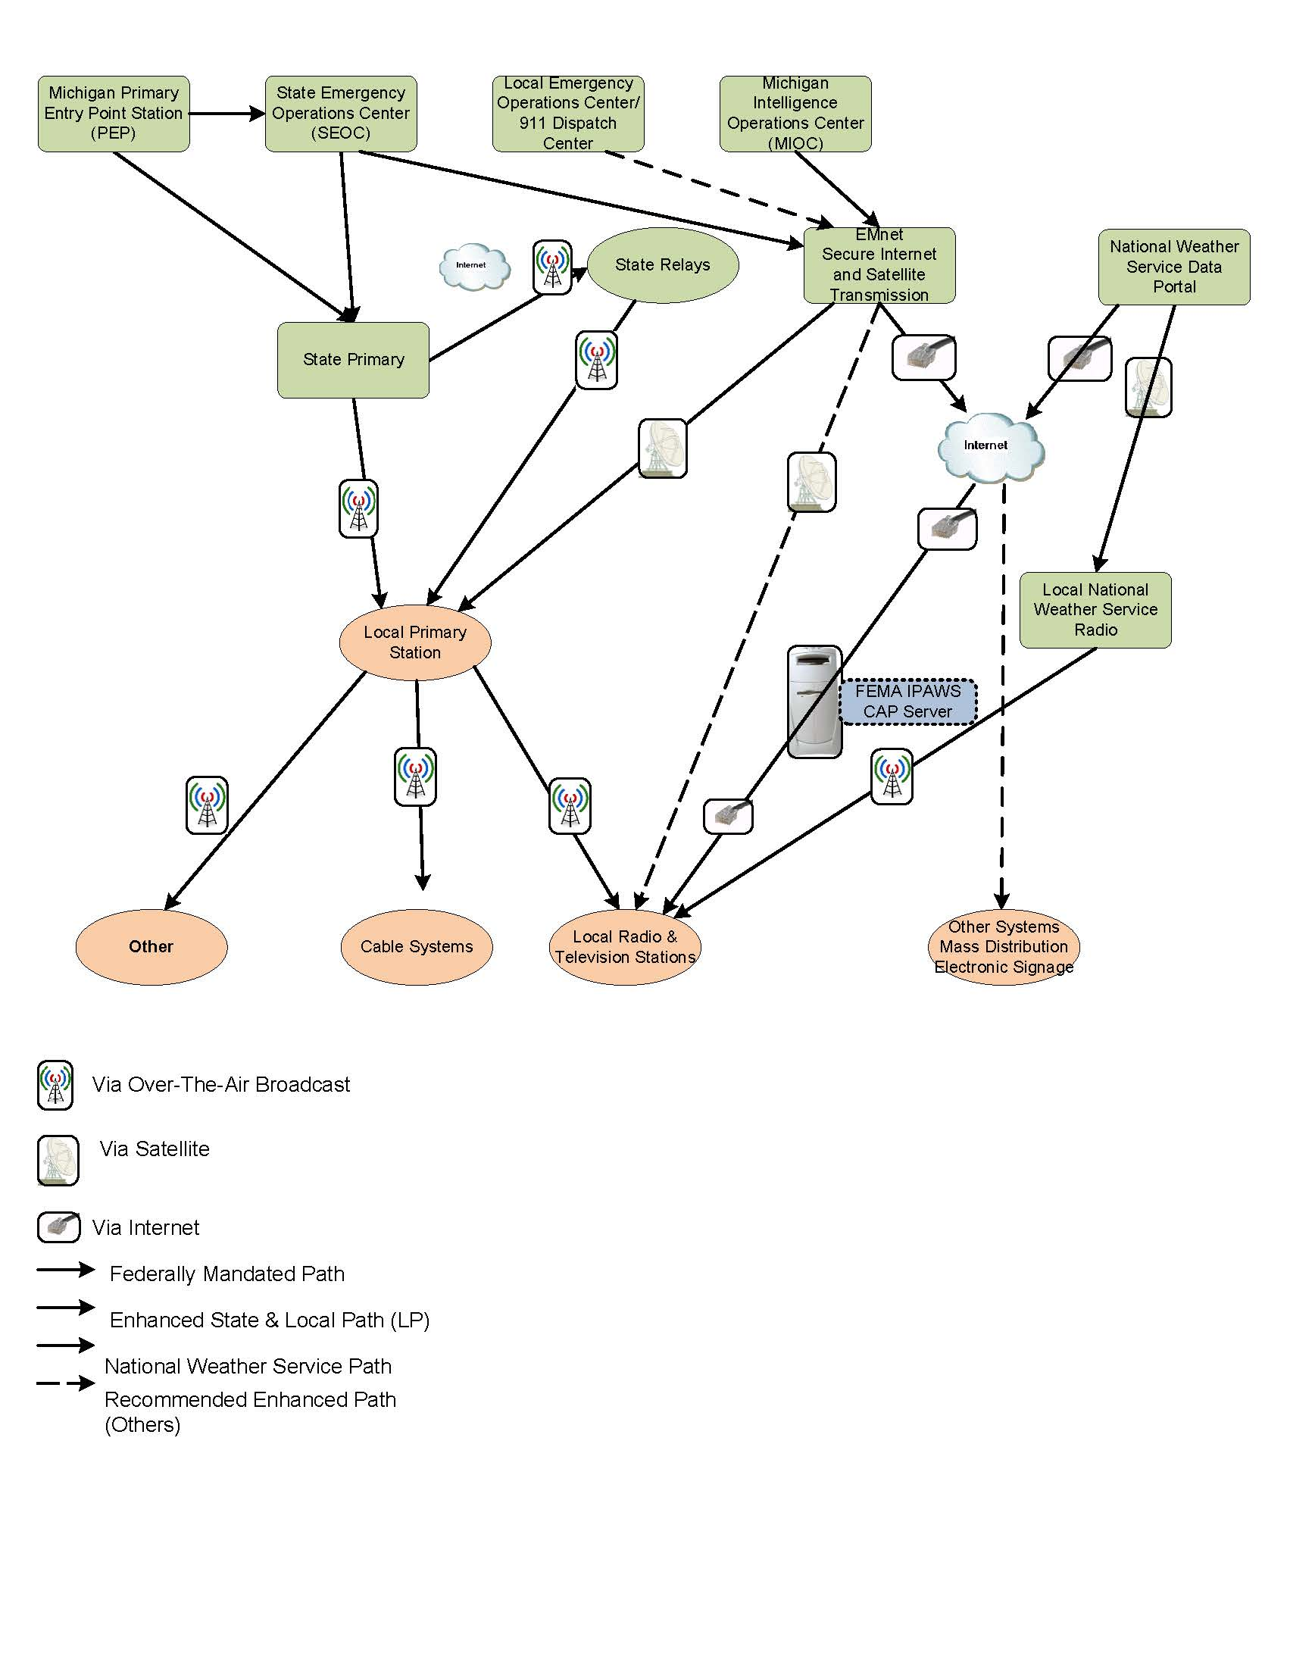

The LP stations across the state will receive the national emergency message from either the SP station or the SR sources, including:

- WCMU-FM (89.5 MHz) and these stations that rebroadcast their signal:
  - 91.7 MHz, Alpena
  - 90.1 MHz, Bay City
  - 103.9 MHz, Harbor Springs
  - 95.7 MHz, Oscoda
  - 98.3 MHz, Sault Ste. Marie
  - 96.9 MHz, Standish
  - 95.1 MHz, Traverse City
- WNMU-FM (90.1 MHz), Marquette
- WUPS (98.5 MHz), Houghton Lake

Designated LPs serve as monitoring sources for all EAS participants in their respective area. Each area at minimum contains a primary LP and at least one alternate LP depending on signal coverage. Each LP shall monitor the SP (WKAR-FM [90.5 MHz], East Lansing) either directly over-the-air, via a SR station, or another method as deemed appropriate by the SECC. The LP shall forward all EAS messages originating nationally or from the Governor and his/her designees in accordance with the forwarding requirements detailed in Section VIII. A., B., and C plan.

EMnet

EMnet is an emergency information dissemination solution utilizing both the Internet and a private satellite communications link to provide redundant encrypted communications. EMnet has been implemented at the State level and in all EAS areas at the LP-1 and LP-2 stations. Additionally, EMnet has been adopted by many county Emergency Management programs and 911 centers. In each region that has implemented EMnet; the capability now exists for County Emergency Operations Centers (CEOC) to disseminate emergency information to their LPs and communicate with other civil authorities using this system.

Many of Michigan’s TV stations are both IPAWS CAP compliant, as well as equipped with EMnet via a module in their encoder. This unique multiple connectivity will allow nearly instantaneous warnings to reach many TV viewers in the State.

Users in regions that do not have either EMnet or other IPAWS-compliant EAS encoder equipment and proper federal authorization have no direct means for activation of any portion of the IPAWS system, including EAS, NWS, CMAS, electronic message signs, and other components. Therefore it is imperative these users purchase necessary equipment and receive federal credentials as soon as possible.

Other broadcast facilities may purchase an EMnet receive terminal for increased speed and reliability of emergency communications. Your station should contact the State EAS Chairman for details to ensure inclusion in this secure network.

VIII. Origins of EAS Information

A. National Level System

The delivery of all national messages as required by FEMA shall come from the White House into the National Primary Entry Point (PEP) network of stations. The Michigan PEP station is WJR (Detroit).

Additionally, a PEP signal is relayed via National Public Radio (NPR) satellite and is received by the SP and other NPR stations. The signal is relayed to the State via over-the-air transmission, relay stations and other distribution methods. The national emergency message (including audio of the President) will be disseminated across the state by every participating broadcast facility and cable system.

The local plan may require all other broadcast stations and cable operators to monitor a National Oceanic and Atmospheric Administration (NOAA) weather radio station. Even if not required by the local plan each station should monitor NOAA weather radio stations or additional local or state relay entities as they wish.

1. National-Level Event Codes

The national level codes are reserved for exclusive use by the federal government and shall be forwarded by all EAS participants upon reception:

Table 2: National EAS Codes
Event Code | Event | Definition
EAN | Emergency Action Notification | An event code used by the EAS to signify a Federal activation of the system. EAN activations are reserved solely for the President of the United States.
NIC | National Information Center | A source of federal government information.
NPT | National Periodic Test | This code is used for a test of national primary sources.

B. State Level System

EAS messages at the state level will be the responsibility of the State Emergency Operations Center. In the event the Governor or other State official authorized to issue a state emergency message is not able to speak from or connect through the SEOC or MIOC, a procedure will be in place so that they may directly contact the State Primary station.

State activation will occur for emergencies that pose an imminent threat to the safety of life and property at the state level or a large regional area. Examples of these wide-spread emergency situations which may warrant an immediate or delayed response by the licensee are: floods, tornadoes, severe icing conditions or snow, widespread fires, widespread discharge of toxic gases, widespread power or communications failures, industrial or nuclear incident and civil disorders.

Broadcast license holders or cable operators shall ascertain whether EAS has been activated by one or all of the following methods:

- Monitor the assigned LP stations
- Monitor the SP; other SR: WUPS (Houghton Lake), WCMU-FM (or one of its network of stations), WNMU (Marquette) or the satellite signal of Michigan Radio Networks
- Monitor the nearest NOAA Weather Radio Station in the area
- Monitor internet, cable and other information sources

2. State-Level Event Codes

The State is authorized to use any of the civil event codes in Table 3 or Table 4 if a situation warrants. Local officials cannot issue the Child Abduction Emergency (CAE) or Civil Emergency Message (CEM) EAS event codes listed in Table 3 as these are reserved for use only by the State. For procedures involving the CAE EAS event code and the Michigan Amber Alert Network refer to your local EAS Area plan.

Table 3: State Reserved EAS Event Codes

Event Code | Event | Definition | Priority for Local Primary | Priority for Others
CAE | Child Abduction Emergency | Also known as the AMBER Alert, this event is only to be used for abductions of children (up to age 17) where police believe the child is in danger of serious bodily harm or death, or the child’s mental or physical circumstances are such that they would be placed in a life-threatening situation.  A local or state law enforcement agency investigating the abduction will describe the missing child, provide a description of the suspect or vehicle, and ask the public to notify the requesting agency if they have any information on the whereabouts of the child or suspect.  Please consult the Michigan State Police AMBER Alert Coordinator for further information at (517) 241-8000. | 3 | 3
CEM | Civil Emergency Message | An emergency message from the governor or a gubernatorial representative regarding an in-progress or imminent, significant and widespread threat(s) to public safety and/or property within the State of Michigan. This may include declaration of martial law, curfews, disasters or emergencies that affect the entire state or large portions thereof. | 1 | 1

C. Local Level System

Dissemination of local emergency messages by broadcasters is voluntary, but strongly encouraged. It is the responsibility of government representatives to work with the SECC and Local Emergency Communications Committees (LECC) to determine what entities have responsibility to issue alerts to broadcast stations and cable systems, set priorities for situations that warrant automatic emergency activations, and establish procedures.

Local EAS activations shall be in accordance with the EAS State Plan and Local Area Plans. Local Area Plans must be submitted to the Michigan SECC for incorporation in the State EAS Plan upon approval. The Local plan should designate which representatives of local government will be authorized to issue an emergency alert. The local plan should specify what entities will issue emergency messages to the broadcast stations, which stations will disseminate emergency alerts and the corresponding circumstances for issuing the alerts.

3. Local-level Event Codes and Priorities

The following event codes shall be used for local-level events only. The originator agency is limited as indicated.

Table 4: Local EAS Event Codes

Event Code | Event | Orig.  Agency | Definitions | Priority For  Local Primary | Priority for Others
ADR | Administrative Message | EAS  CIV  WXR | A non-emergency message that provides updated information about an event in progress, an event that has expired or concluded early, pre-event preparation or mitigation activities, post-event recovery operations, or other administrative matters pertaining to the EAS | Log Only | Log Only
BZW | Blizzard Warning | WXR | A warning of current or imminent blizzard-like conditions that pose a significant threat to public safety and/or property. Probability of occurrence and location is high and the onset time is relatively short. Blizzards are characterized by a high amount of snowfall, reduced visibility and strong winds. Blizzards are different from winter storms due to the lack of ice-like precipitation. | 3 | 3
CDW | Civil Danger  Warning | CIV | A warning of an event of a terrorist or military nature that presents a danger to a significant civilian population. The CDW usually warns of a specific hazard and gives specific protective action. Examples include contaminated water supply and imminent or in-progress military or terrorist attack. Public protective actions could include actions such as boiling contaminated water or seeking medical treatment. | 1 | 1
CFW | Coastal Flood Warning | WXR | A warning of current or imminent coastal flooding that poses a significant threat to public safety and/or property. Probability of occurrence and location is high and the onset time is relatively short. Coastal flooding is characterized by rising ocean, lake and estuarine waters that will cause flooding in surrounding regions. | 3 (L) | 3 (L)
DMO | Practice Demo | EAS  CIV | This code is used for training personnel and testing emergency warning equipment and is not intended to be aired or logged. | No Action | No Action
EVI | Evacuation Warning | CIV | A warning where immediate evacuation is recommended or ordered. As an example, in the event a flammable or explosive gas is released, authorized officials may require evacuation of designated areas where casualties or property damage from a vapor cloud explosion or fire may occur. | 1 | 1
FFW | Flash Flood Warning | WXR | A warning of current or imminent flash flooding that poses a significant threat to public safety and/or property. Probability of occurrence and location is high and the onset time is relatively short. Flash floods are driven by intense rain or snow/ice melt over a short period of time. The unrestrained flooding of water from river or stream sources over a short period of time defines flash floods from regular flood warnings. Example: Heavy rains flooding a roadway not located by pre-existing water sources. | 3 (L) | 3 (L)
FRW | Fire Warning | CIV  WXR | A warning of a spreading wildfire or structural fire that threatens a large populated area. | 2 | 2
HMW | Hazardous Material Emergency | CIV | A warning in which the public is advised of a release of a material that is hazardous to their health in a specific area. Examples include release of non-radiological materials such as various chemicals agents, corrosive acids and liquids. | 1 | 1
LAE | Local Area Emergency | CIV | An emergency message that defines an event that provides serious danger or threat health or safety, issued by authorized officials. Examples include: a significant disruption in water, electric or natural gas service, road closures that prohibit emergency personnel to provide services. | 3 | 3
LEW | Law Enforcement Warning | CIV | A warning of a terror threat, Law Enforcement Officer injured or killed, with suspect at‐large,or other criminal event. Authorized law enforcement agency may blockade roads,water ways, or facilities, evacuate or deny access to affected areas, and arrest violators or suspicious persons. | 1 | 1
NUW | Nuclear Power Plant Warning | CIV | A warning of an event at a nuclear power plant classified as a General Emergency as classified by the U.S. Nuclear Regulatory Commission (NRC). A Site Area Emergency is confined to the plant site; no off-site impact is expected. Typically, a General Emergency is confined to an area less than a 10-mile radius around the plant. Authorized officials may recommend evacuation or medical treatment for exposed persons in nearby areas. | 1 (L) | 1 (L)
RHW | Radiological Hazard Warning | CIV | A warning of the loss, discovery or release of a radiological hazard. Examples include: the theft of a radioactive isotope used for medical, seismic or other purposes; the discovery of radioactive materials; a transportation (aircraft, truck or rail, etc.) accident which may involve nuclear weapons, nuclear fuel or radioactive wastes. Authorized officials may recommend protective actions to be taken if a radioactive hazard is discovered. | 1 | 1
RMT | Required Monthly Test | EAS  CIV | Federally-mandated test of EAS that occurs on a monthly basis. It is scheduled in advance according to a federally prescribed rotation of day and night tests and broadcast by local primary stations. | 3 | 4
RWT | Required Weekly Test | EAS  CIV  WXR | Federally-mandated test of EAS that occurs on a weekly basis at a random interval on each broadcast station and cable system. | Log Only | Log Only
SPW | Shelter in Place Warning | CIV | A warning of an event where the public is told to shelter-in-place (go inside, close doors and windows, turn off ventilation systems that can bring in outside air and turn on the radio or TV for more information). An example is the release of hazardous materials where toxic fumes or radioactivity may affect designated areas. | 2 | 2
SVR | Severe Thunderstorm Warning | WXR | Thunderstorm warnings indicate a thunderstorm that poses a significant threat to public safety and/or property, probability of occurrence and location is high, and the onset time is relatively short. Severe thunderstorms can contain lighting, hail, heavy rains and high winds in excess of 58 MPH. | 2 | 2
TOE | 911 Telephone Outage Emergency | CIV | An emergency message that defines a local or state 911 telephone network outage by geographical area or telephone exchange. Authorized officials may provide alternative phone numbers in which to reach 911 or dispatch personnel. | 2 | 2
TOR | Tornado Warning | WXR | A warning for a tornado that poses a significant threat to public safety and/or property, probability of occurrence and location is high, and the onset time is relatively short. Tornadoes are characterized by funnel clouds possessing high winds and damaging hail. | 1 | 1

Table 5: Explanation of Event Code Priorities for Tables 3, 4
Priority | Action
1 | Transmit immediately or within sixty seconds of receipt
2 | Transmit within five minutes of receipt
3 | Transmit within fifteen minutes of receipt
4 | Transmit within sixty minutes of receipt
Log Only | Do not transmit
(L) | Use of this code is specified in the EAS Local Plan

EAS Message Priorities

EAS priorities are set forth in the FCC Rules as follows:

- A National activation of the EAS for a {Presidential message with the Event code EAN or test code NPT as specified in FCC Part 11.31 must take priority over any other message and preempt it, if it is in progress.
- EAS participants should transmit other EAS messages in the following order:
  - Local Area Messages
  - State Messages
  - National information Center ( NlC) Messages
- Key EAS sources National Primary, State Primary, State Relays, Local Primary and Participating National are sources that remain on the air during a National Emergency and must carry Presidential Messages "live" at the time of transmission or immediately upon receipt.
- Activation of the National level EAS must preempt State and Local area EAS operation.
- During a national emergency the radio and television broadcast network program distribution facilities must be reserved exclusively for distribution of Presidential Messages. NIC messages received from national networks which are not broadcast at the time of original transmission must be recorded locally by Local Primary sources for transmission at the earliest opportunity consistent with the message priorities in paragraph 2 of this section.

IX. Required EAS Testing

Required Monthly Test (RMT)

Required Monthly Tests (RMT) are initiated on a statewide and local area basis. The SECC will coordinate and assign responsibility for initiating two required monthly tests per year. The SECC will solicit participation from the MSP/EMHSD and will coordinate with the NWS to conduct tests that demonstrate the dissemination of emergency messages to local broadcasters and cable operators.

Testing shall conform to the following pattern, alternating between LPs and day and night tests:

Table 6: Monthly Testing Parameters

Month | Time Frame | Station | Originating Source
January | Daytime: 8:30 AM to Local Sunset | LP-1 | County EOC or Station Staff
February | Nighttime: Local Sunset to 8:30 AM | LP-2 | County EOC or Station Staff
March | Daytime: 8:30 AM to Local Sunset | SP | State EOC
April | Nighttime: Local Sunset to 8:30 AM | LP-1 | County EOC or Station Staff
May | Daytime: 8:30 AM to Local Sunset | LP-2 | County EOC or Station Staff
June | Nighttime: Local Sunset to 8:30 AM | LP-2 | County EOC or Station Staff
July | Daytime: 8:30 AM to Local Sunset | LP-1 | County EOC or Station Staff
August | Nighttime: Local Sunset to 8:30 AM | LP-1 | County EOC or Station Staff
September | Daytime: 8:30 AM to Local Sunset | LP-2 | County EOC or Station Staff
October | Nighttime: Local Sunset to 8:30 AM | SP | State EOC
November | Daytime: 8:30 AM to Local Sunset | LP-1 | County EOC or Station Staff
December | Nighttime: Local Sunset to 8:30 AM | LP-2 | County EOC or Station Staff

Each LECC will direct the airing of a required monthly test, with the exception of the state required monthly tests. These tests shall use the Event Code “RMT”. Testing shall be conducted per FCC directives that require an alternation of LP-1 and LP-2 stations and day and night testing. All other broadcasters and cable operators are to wait for this test and then respond as described below.

The schedule for these tests should be determined one year in advance by each LECC. This schedule is to be published and distributed to each station and cable operator within the EAS Area as well as a copy to the Chairperson of the SECC. For training purposes, the LECC should strive to have the tests originated whenever possible by Emergency Managers or 911 Centers of the counties in the EAS area.

For AM daytime only stations EAS units will not allow transmission of a message that was received while the station was off the air as the message will be expired. Lacking a valid RMT at sign on, the station must create then air and log a Required Weekly Test (RWT) with 15 minutes of sign-on.

1. Recommended Test Times

Judgment will be exercised in the scheduling of times for the RMT. All broadcasters and cable operators are required to rebroadcast this test. Care must be taken to avoid hardship on broadcasters when they are carrying their highest-revenue programming. These periods would include morning and afternoon radio drive time, newscasts, prime access and prime time periods. Each committee should consider the time in the hour the test occurs since it must be rebroadcast within 60 minutes of receipt.

Television stations airing “self-contained” type programs with no interruption points and radio stations with similar programs or airing classical music might find difficulty airing a RMT if it occurs mid-hour. The least obtrusive time is just before the top of an hour at a natural program break near the station identification time.

Broadcasters and cable operators with a complaint regarding the scheduling of the RMT in their area should make their concerns known to their Local Area EAS Chair. If a satisfactory resolution is not reached at that level the State EAS Chair should be contacted.

2. Reception and Retransmission of the RMT

The SP stations will re-transmit any national or state emergency messages immediately. State relays are strongly urged to retransmit EAS messages and required tests immediately or no later 15 minutes of receipt.

All broadcasters and cable operators receiving the RMT test should re-transmit this test within 60 minutes of receiving the test. For daytime-only stations receiving a night-time RMT, a RWT must be re-transmitted within 15 minutes of the daytime-only station’s sign-on. Transmission of the RWT by the day-time only station will replace the RMT. Times should be logged for both the receipt and re-transmission of the RMT test.

Broadcast and cable management should communicate to staff that re-transmission of this test is not an option. It is a FCC violation to fail to re-transmit the required monthly test within 60 minutes of receiving the test.

Some EAS encoder/decoders unit may be set for an automatic countdown upon receiving an RMT (Semi-Automatic Timed Auto Forward Mode). This allows the EAS unit to automatically transmit the test if the operator fails to do so manually within a reasonable time.

3. Required Weekly Test (RWT)

All broadcasters and cable operators must transmit a RWT once each week at random days and times except for the week of the RMT. There are no time-of-day restrictions. This is approximately a 10 second test consisting of the EAS Header and End-of-Message Codes. Additional text to explain the test to listeners and/or viewers may be included. All broadcasters and cable operators receiving a RWT from one of their monitored sources must log receipt of this test. No further action is required.

Each broadcast station and cable operator may decide when to conduct the randomly scheduled weekly test.

X. EAS Equipment and Operations Guidelines

Programming Your Encoder/Decoder Unit

Stations are encouraged to configure their EAS encoders for automatic relay of all EAS messages. EAS participants should consult the manual for their unit for specific programming instructions. Unattended stations must operate EAS encoders for automatic relay of EAS messages. Each broadcast station and cable system can exercise discretion regarding the broadcast of emergency information to the general public by the FCC.

This section is provided to assist users of the EAS in programming the Event Codes, County Location Codes and Modes of Operation into their EAS Decoder. This information can also assist emergency services and nuclear/industrial plant personnel making use of the Decoder section in their EAS equipment.

1. Modes of Operation

All EAS Decoders are capable of Manual and Automatic Operation. Most manufacturers also offer a Semi-Automatic Mode.

2. Manual Operation

In the manual mode, EAS equipment will only notify you of any incoming EAS Alerts that have been programmed. Your operator must manually cause the Alert to be re-transmitted on your station/cable system. This mode should only be used by stations or cable systems with operators on duty at all times that the station or cable system is in operation.

3. Automatic Operation

In the Automatic mode when the EAS Decoder receives an EAS Alert, it is programmed to respond to it immediately and interrupts programming to transmit the EAS Alert.

FCC EAS regulations require immediate broadcast of any Emergency Action Notification (EAN) or Emergency Action Termination (EAT) coded alerts. The EAS unit for broadcast stations and cable systems would normally be used with a Program Interrupt type connection. The on-air audio is "looped through" the EAS unit so the unit can interrupt the audio when necessary, or a relay contact is provided to perform the audio interruption function.

Television stations are required to transmit emergency information visually and aurally. The EAS unit is capable of interfacing with video character generators capable of automatically inserting a video crawl at the top of the screen. EAS equipment manufacturers can supply the character generator or stations can interface their own external character generator.

In a cable system, use of video and audio information may be displayed on all channels, a single channel with an attention text displayed on all channels or a forced re-tune of the cable box to an information channel until the end of the message occurs.

4. Semi-Automatic Operation

Under this mode of operation when the EAS Decoder receives a programmed EAS Alert, it will begin a preset countdown to automatic interruption. This allows the operator to run the EAS Alert on the air manually at their earliest convenience. If the Alert is not run by the time the preset countdown time expires, the EAS equipment will automatically broadcast the alert. This would apply to a broadcast automation system where the automation system should insert the received Alert in the next commercial break. If the broadcast automation system fails to insert the receiver Alert during the commercial break, the EAS equipment will broadcast at the end of the time-out.

Some EAS units allow great flexibility in responding to event types in various modes such as weather watches in manual mode and all weather warnings in the automatic mode. For example, the Required Monthly Test (RMT) could be programmed for Semi-Automatic Mode with a 30 minute countdown. This would give the operator the opportunity to run the RMT at a logical break in the show. But if the time is exceeded, the EAS equipment would then perform the test automatically within the time limit of 60 minutes.

Unattended Operation

Broadcasters using “Unattended Operation” and most cable operators must run their EAS equipment in the Automatic Mode.

Care should be exercised in the programming of the EAS unit for your facility. An error in programming could result in missing EAS warnings vital to the safety of your listening and viewing audiences.

6. County Location Codes

Selection of the appropriate FIPS codes for the counties of interest should be based upon the station’s or cable system’s effective coverage area. A cable system should include only the county in which their customers live. A television or large FM station that provides service over many counties may find their FIPS code list is quite large. Depending on the station’s location, FIPS codes for adjoining EAS areas or counties from adjoining states may be appropriate. Please see Appendix G for a list of all FIPS codes for the state of Michigan.

7. CAP Compliance

All broadcast stations and cable systems must employ equipment that is approved to correctly receive a FEMA IPAWS CAP (Common Alerting Protocol) based message. This equipment must have a full-time connection to the internet.

Guidance for Originators of EAS Messages

Only those entities specifically authorized by the applicable LECC and/or the SECC shall input emergency messages into the EAS. Following is some basic guidance for the various originators of EAS messages:

1. Law Enforcement

The EAS is designed so that agencies with an emergency message may create it only once and it is received by all area broadcasters and cable operators simultaneously. A local plan is essential to establish the most efficient and effective way to communicate with Local Primary stations or other broadcasters and cable operators in each area.

To generate an EAS message, the Michigan State Police and many county emergency management operations have installed EMnet. This system provides a CAP compliant encoder and is a secure, multi-path messaging system. Emergency services personnel are encouraged to contact either their local Chairperson or the SECC with any questions or concerns.

2. National Weather Service (NWS)

NWS personnel should issue EAS Weather Alerts via the NOAA data system and NOAA weather radio using NWS EAS Codes. NWS procedures should be followed for transmission of the EAS Codes, the 1050 Hz Alert Tone and the reading of the weather bulletin script. Messages should be clear and concise. The public should be directed to seek additional information by listening to their local television or radio station, or NOAA weather radio.

The NOAA All-Hazards Emergency Message Collection System, or HazCollect for short, is a nationwide capability developed by the National Weather Service (NWS) in coordination and cooperation with the U.S. Department of Homeland Security/FEMA. HazCollect offers emergency services officials’ full distribution of critical emergency messages through NWS channels and Supports Emergency Support Function (ESF) #2-Communication Annex of the National Response Framework.

NWS will not originate alerts that are non-weather emergencies via HazCollect.

Emergency personnel may issue emergency alerts through their EMnet terminal or by approved 3rd party software into the NWS HazCollect system. Authorization to issue alerts by non-NWS personnel requires inclusion in Collaborative Operating Groups (COGS), Common Alerting Protocol (CAP) compliant equipment, and other requirements. See Appendix L for FEMA COG procedures. Appendix M provides a map illustrating the coverage areas of NWS radio in Michigan. Please note that NWS radio does not cover many areas, nor is it partially CAP compliant at the present time.

3. Nuclear

Nuclear plants are to issue EAS Alerts through their county emergency management agency or representative. EAS alert warnings should only be issued for life-threatening emergencies. Alerts for less-serious conditions could compromise the confidence of local broadcasters and cable operators who carry alerts on a voluntary basis. Specific procedures for EAS areas with nuclear plants are included in the Local Area EAS Plans.

Appendix A: Members of SECC and LECC Chairmen

Appendix A-1: Members of SECC

Regions/Agencies | Chairman/Vice Chairman | Contact Name | Email
AT&T | Representative | Scott Kowalczyk | sk1293@att.com
Central | Chairman | Shawn Hoskey | hoske1st@cmich.edu
Central | Vice Chairman | Craig Bowman | the1craig@chartermi.net
Charter | Representative | Bill Swift | billswift@charterinternet.com
Comcast | Representative | Rob Austin | robert_austin@cable.comcast.com
Comcast | Representative | Robert Robinson | robert_robinson@cable.comcast.com
East Central | Chairman | Paul Manning | Paul.manning@cumulus.com
MAB | EAS State Chairman | Gary Blievernicht | garyb@wkar.msu.edu
MAB | President/CEO | Karole White | Karolewhite@michmab.com
MAB | Representative | Alisha Clack | clack@michmab.com
MEMA | Representative | Marc Griffis | mgriffis@isabellacounty.org
MEMA | Representative | Scott Corbin | SCorbin@allegancounty.org
MEMA | Representative | Greg Williams | gwilliams@cceoem.net
MI Coalition of Deaf and Hard of Hearing | Representative
MSP | Representative | Don Bouffard | Bouffardd@michigan.gov
NOAA | Representative | James Maczko | james.maczko@noaa.gov
NOAA | Representative | Richard Pollman | richard.pollman@noaa.gov
Northeastern | Chairman | Steve Wright | swright@watz.com
Northwestern | Chairman | Del Reynolds | reynolds@upnorth.net
Northwestern | Chairman | Jack O'Malley | jacko@wtcmradio.com
RACES | RACES State Coordinator | John McDonough | wb8rcr@arrl.net
South Central | Chairman | Gary Blievernicht | garyb@wkar.msu.edu
South Central | Member | Jason Walther | Jason.walther@townsquaremedia.com
Southeastern | Chairman | Keith Bosworth | keith.bosworth@cumulus.com
Southeastern | Vice Chairman | Robert Ostazewski | raostazewski@cbs.com
Southeastern | Member | Kevin Hawley | 2kevin.hawley@gmail.com
Southwest | Chairman | Dale Schiesser | dale.schiesser@townsquaremedia.com
Southwest | Co-Chairman | Tim Collins | Tim.Collins@townsquaremedia.com
Southwest | Vice Chairman | Terry Green | tgreen@wirx.com
UP Central | Vice Chairman
UP Central | Chairman | Mike Perucco | miperucc@nmu.edu
UP Eastern | Chairman | Tom Ewing | tomewing@charter.net
UP Eastern | Vice Chairman | Coral Howe | coral@wjpd.com
UP Northwest | Chairman | Kevin Ericson | opsmgr@up.net
UP West | Contact | Chuck Gervasio | wupm@wupm-whry.com
Washtenaw-Lenawee | Vice Chairman | Erik Jones | erik.jones@cumulus.com
Washtenaw-Lenawee | Chairman | Ray Cryderman | ray.cryderman@emich.edu
West Central | Chairman | Steve Albert | albert@bluelake.org
West Central | Vice Chairman | Todd Mohr | Todd@synergybroadcast.net
Western | Chairman | Don Missad | missad@woodradio.com
Western | Vice Chairman | Mike Maciejewski | mikem@gogrand.com

* Private phone numbers are available to participants in the Michigan EAS system.

Appendix A-2: SECC EAS Member Chairmen

Regions | Chairman/Vice Chairman | Contact Name | Email
Central | Chairman | Shawn Hoskey | hoske1st@cmich.edu
Central | Vice Chairman | Craig Bowman | the1craig@chartermi.net
East Central | Chairman | Paul Manning | Paul.manning@cumulus.com
Northeastern | Chairman | Steve Wright | swright@watz.com
Northwest | Chairman | Del Reynolds | reynolds@upnorth.net
Northwest | Chairman | Jack O'Malley | jacko@wtcmradio.com
South Central | Chairman | Gary Blievernicht | garyb@wkar.msu.edu
South Central | Vice-Chairman
Southeastern | Chairman | Keith Bosworth | keith.bosworth@cumulus.com
Southeastern | Vice Chairman | Robert Ostazewski | raostazewski@cbs.com
Southwest | Chairman | Dale Schiesser | dale.schiesser@cumulus.com
Southwest | Co-Chairman | Tim Collins | Tim.Collins@cumulus.com
Southwest | Vice Chairman | Terry Green | tgreen@wirx.com
UP Central | Vice Chairman
UP Central | Chairman | Mike Perucco | miperucc@nmu.edu
UP Eastern | Chairman | Tom Ewing | tomewing@charter.net
UP Eastern | Vice Chairman | Coral Howe | coral@wjpd.com
UP Northwest | Chairman | Kevin Ericson | opsmgr@up.net
UP West | Contact | Chuck Gervasio | wupm@wupm-whry.com
Washtenaw/Lenawee | Vice Chairman | Erik Jones | Erik.jones@cumulus.com
Washtenaw/Lenawee | Chairman | Ray Cryderman | ray.cryderman@emich.ed\u
West Central | Chairman | Steve Albert | albert@bluelake.org
West Central | Vice Chairman | Todd Mohr | todd@synergybroadcast.com
Western | Chairman | Don Missad | missad@woodradio.com
Western | Vice Chairman | Mike Maciejewski | mikem@gogrand.com

Appendix B: Officials Authorized to Issue EAS for the State of Michigan

Name | Title | Address
Rick Snyder | Governor | P.O. Box 30013  Lansing, Michigan 48909
Brian Calley | Lieutenant Governor | P.O. Box 30013  Lansing, Michigan 48909
Colonel Kriste Kibbey Etue | State Director of Michigan State Police | 333 Grand Avenue  Lansing, MI 489909

Appendix C: State Local Primary Stations

EAS Area | ID # | LP Status | Call Letters | Freq | General Manager | Phone | Chief Engineer | Phone
South Central | 1 | LP-1 | WFMK-FM | 99.1 | Chris Tyler | 616-774-8461 | Jason Walther | 517-394-7272
South Central | 1 | LP-2 & SP | WKAR-FM | 90.5 | Susi Elkins | 517-884-4750 | Drew Henderson | 517-884-4748
East Central | 2 | LP-1 | WHNN-FM | 96.1 | Scott Meir | 989-776-2100 | Paul Manning | 989-776-2182
East Central | 2 | LP-2 | WIOG-FM | 102.5 | Scott Meir | 989-776-2100 | Paul Manning | 989-776-2182
East Central | 2 | LP-3 | WCEN-FM | 94.5 | Shannone Dunlap | 989-752-3456 | Geary Morrill | 989-752-3456
East Central | 2 | LP-4 | WKJC-FM | 104.7 | John Carroll, Jr. | 989-362-3417 | Marvin Walther | 989-362-3417
Northeastern | 3 | LP-1 | WATZ-FM | 99.3 | Mike Centala | 989-354-8400 | Mark Nowak | 989-354-8400
Northeastern | 3 | LP-2 | WHSB-FM | 107.7 | Darrel Kelly | 989-354-4611 | Darrel Kelly | 989-354-4611
Northwestern | 4 | LP-1 | WTCM-FM | 99.3 | Chris Warren | 231-947-7675 | Jim Sofonia | 231-947-7675
Northwestern | 4 | LP-2 | WMKC-FM | 102.9 | Del Reynolds | 231-627-2341 | Del Reynolds | 231-627-2341
Southeastern | 5 | LP-1 & PEP | WJR-AM | 760 | Tom O'Brien | 313-875-4440 | Keith Bosworth | 313-875-4440
Southeastern | 5 | LP-2 | WWJ-AM | 950 | Debbie Kenyon | 248-855-5100 | Robert Ostazewski | 248-455-7200
Southwestern | 6 | LP-1 | WKFR-FM | 103.3 | Scott Meier | 616-344-0111 | Dale Schiesser | 269-344-4223
Southwestern | 6 | LP-2 | WVFM-FM | 106.5 | Peter Tanz | 269-488-3801 | Walker Sisson | 269-349-9898
Southwestern | 6 | LP-3 | WBXX-FM | 104.9 | Tim Collins | 269-963-5555 | Walker Sisson | 269-349-9898
Southwestern | 6 | LP-4 | 4Q-FM | 99.9 | Sally Brown | 574-233-3141 | Mike Green | 574-233-3141
Southwestern | 6 | LP-5 | WCXT-FM | 98.3 | Dave Doetsch | 269-925-1111 | Terry Green | 269-925-1111
U.P.-Central | 7 | LP-1 & SR | WNMU-FM | 90.1 | Eric Smith | 906-227-9668 | Mike Perruco | 906-227-1330
U.P.-Central | 7 | LP-2 | WGLQ-FM | 97.1 | Richard Duerson | 906-789-9700 | Allan Augustyn | 906-789-9700
U.P. Central | 7 | LP-3 | WJPD-FM | 92.3 | Bill Curtis | 906-225-1313 | Coral Howe | 906-225-1313
U.P.-Eastern | 8 | LP-1 | WSUE-FM | 101.3 | Tom Ewing | 906-632-2231 | Coral Howe | 231-347-8713
U.P. Eastern | 8 | LP-2 | WIHC-FM | 102.9 | Del Reynolds | 231-627-2341 | Coral Howe | 231-627-2341
U.P.-Northwestern | 9 | LP-2 | WGLI-FM | 98.7 | Ed Janise | 906-353-9287 | Ron Gnadinger | 906-353-9287
U.P.-Northwestern | 9 | LP-1 | WOLV-FM | 97.7 | Kevin Ericson | 906-482-7700 | Ron Gnadinger | 906-353-9287
U.P.-Western | 10 | LP-1 | WIMI-FM | 99.7 | Steve Resnick | 906-932-2411 | Ted Franz | 906-884-9668
U.P.-Western | 10 | LP-2 | WUPM-FM | 106.9 | Charles H. Gervasio | 906-932-5234 | Alan Harrison | 906-932-5234
Washtenaw –Lenawee | 11 | LP-1 | WEMU-FM | 89.1 | Mary Motherwell | 734-487-2229 | Ray Cryderman | 734-487-2229
Washtenaw –Lenawee | 11 | LP-2 | WWWW-FM | 102.9 | Scott Meir | 734-302-8100 | Erik Jones | 734-302-8100
Western | 12 | LP-1 | WSRW-FM | 105.7 | Tim Feagan | 616-459-1919 | Don Missad | 616-459-1919
Western | 12 | LP-2 | WLHT-FM | 95.7 | Russ Hines | 616-451-4800 | Mike Maciejewski | 616-459-1678
Central | 13 | LP-1 & SR | WCMU-FM | 89.5 | Ed Grant | 989-774-3105 | Wayne Henderson | 989-774-6864
Central | 13 | LP-2 & SR | WUPS-FM | 98.5 | Cindy Fuller | 989-366-5364 | Craig Bowman | 989-277-8835
West Central | 14 | LP-1 | WBLV-FM | 90.3 | Dave Myers | 231-894-5656 | Don Hoogeboom | 231-894-5656
West Central | 14 | LP-2 | WWKR-FM | 94.1 | Richard Young | 231-843-0941 | Tom Green | 231-843-0941

Appendix D: Monitoring Charts by Areas

Appendix D-1: Southeastern

Call Letters | Frequency | LP
WJR-AM | 760 | LP-1
WWJ-AM | 950 | LP-2

Appendix D-2: Southwestern

Call Letters | Frequency | LP
WKFR-FM | 103.3 | LP-1
WVFM-FM | 106.5 | LP-2
WBXX-FM | 104.9 | LP-3
WQLQ-FM | 99.9 | LP-4
WCXT-FM | 98.3 | LP-5

Appendix D-3: South Central

Call Letters | Frequency | LP
WFMK-FM | 99.1 | LP-1
WKAR-FM | 90.5 | LP-2

Appendix D-4: Washtenaw-Lenawee

Call Letters | Frequency | LP
WEMU-FM | 89.1 | LP-1
WWWW-FM | 102.9 | LP-2

Appendix D-5: Western

Call Letters | Frequency | LP
WSRW-FM | 105.7 | LP-1
WLHT-FM | 95.7 | LP-2

Appendix D-6: West Central

Call Letters | Frequency | LP
WBLV-FM | 90.3 | LP-1
WWKR-FM | 94.1 | LP-2

Appendix D-7: Northwestern

Call Letters | Frequency | LP
WTCM-FM | 103.5 | LP-1
WMKC-FM | 102.9 | LP-2

Appendix D-8: Central

Call Letters | Frequency | LP
WCMU-FM | 89.5 | LP-1
WUPS-FM | 98.5 | LP-2

Appendix D-9: East Central

Call Letters | Frequency | LP
WHNN-FM | 96.1 | LP-1
WIOG-FM | 102.5 | LP-2
WCEN-FM | 94.5 | LP-3
WKJC-FM | 104.7 | LP-4

Appendix D-10: Northeastern

Call Letters | Frequency | LP
WATZ-FM | 99.3 | LP-1
WHSB-FM | 107.7 | LP-2

Appendix D-11: Upper Peninsula – Eastern

Call Letters | Frequency | LP
WSUE-FM | 101.3 | LP-1
WIHC-FM | 102.9 | LP-2

Appendix D-12: Upper Peninsula – Central

Call Letters | Frequency | LP
WNMU-FM | 90.1 | LP-1
WGLQ-FM | 97.1 | LP-2
WJPD-FM | 92.3 | LP-3

Appendix D-13: Upper Peninsula – Western

Call Letters | Frequency | LP
WIMI-FM | 99.7 | LP-1
WUPM-FM | 106.9 | LP-2

Appendix D-14: Upper Peninsula – Northwestern

Call Letters | Frequency | LP
WOLV-FM | 97.7 | LP-1
WGLI-FM | 98.7 | LP-2

Appendix D-15: Local Primary Station’s Monitoring Chart:

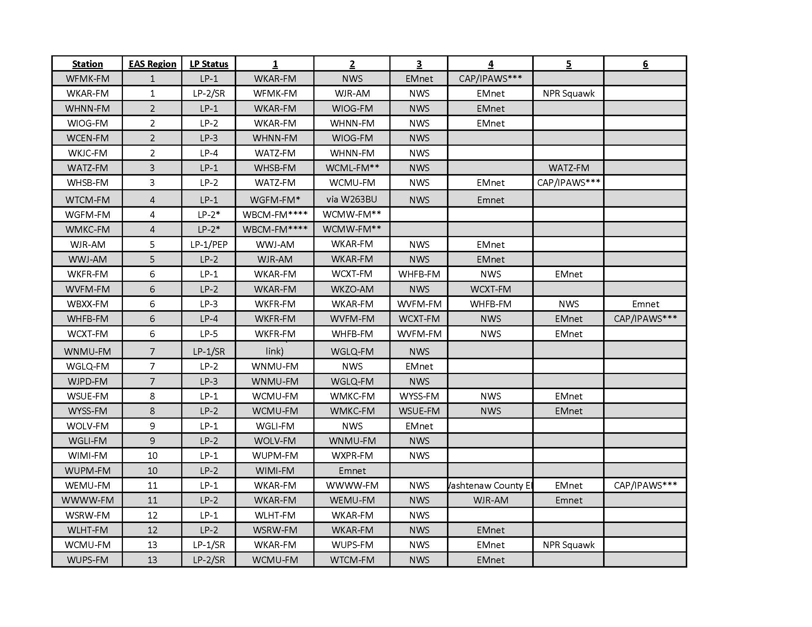

Appendix D-16: State Monitoring Assignments for all stations:

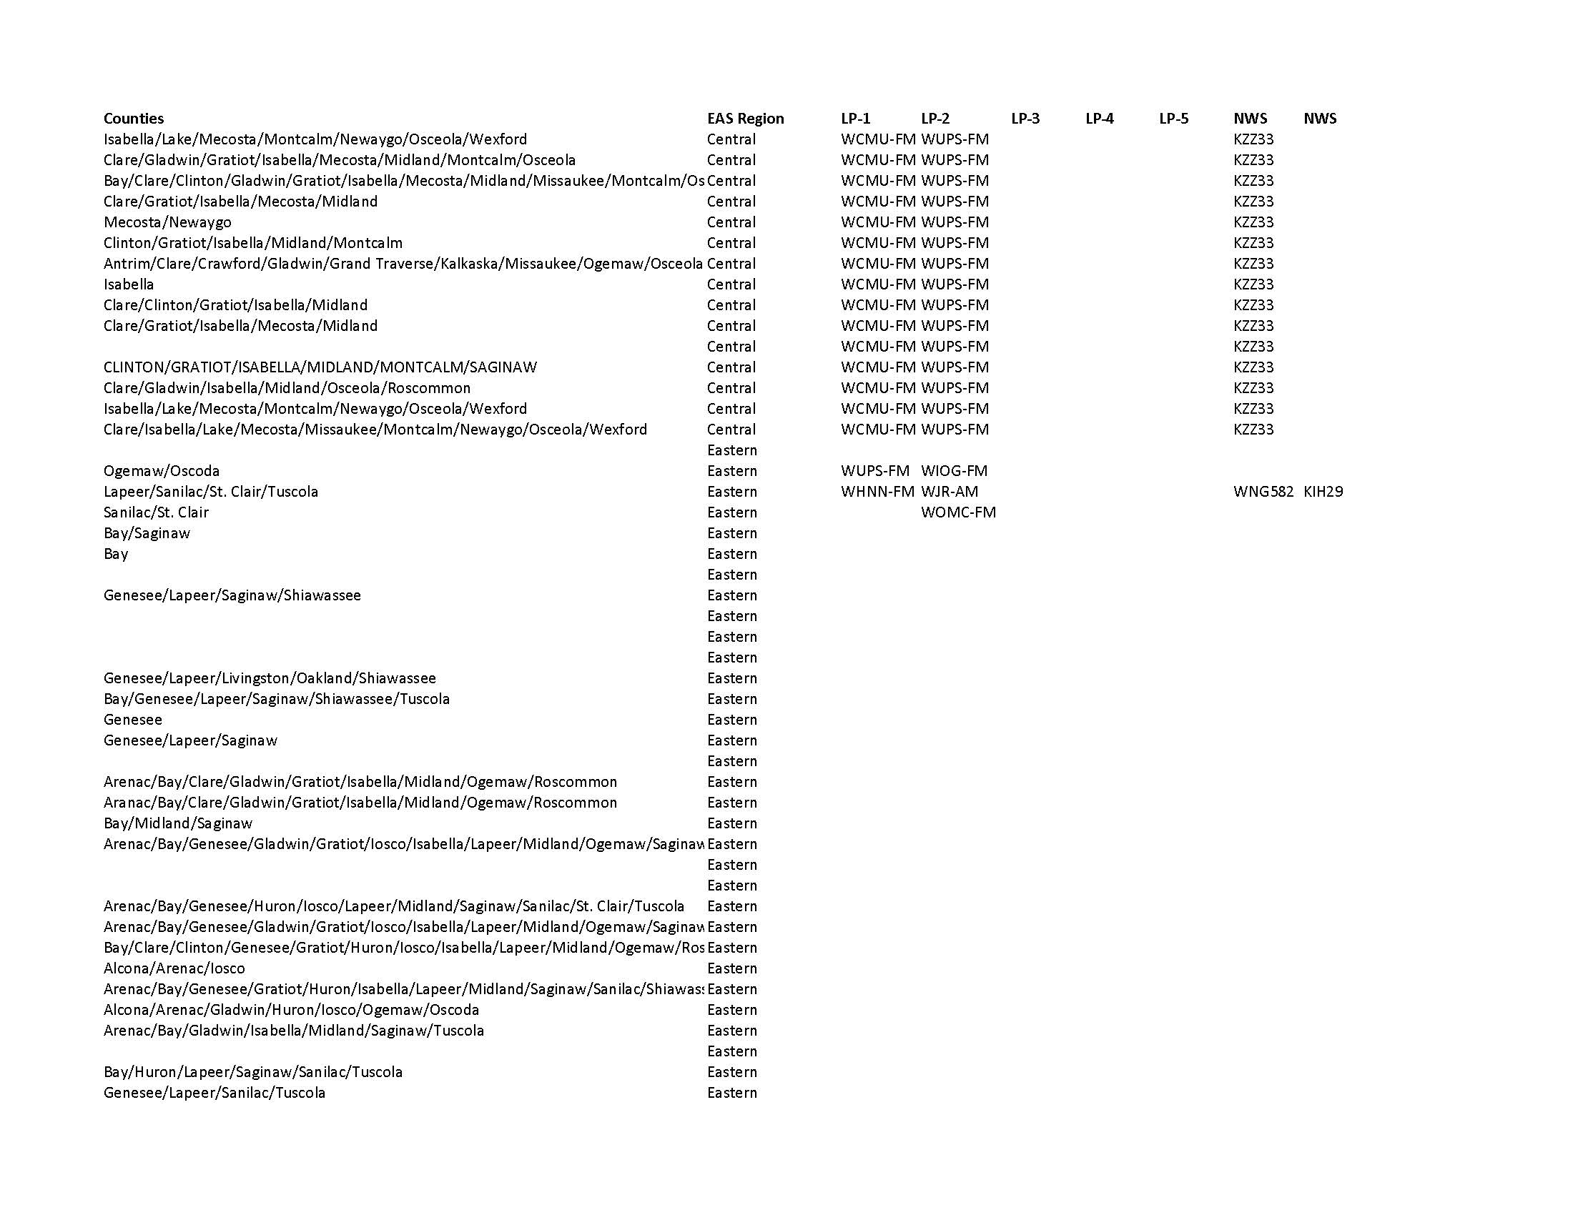

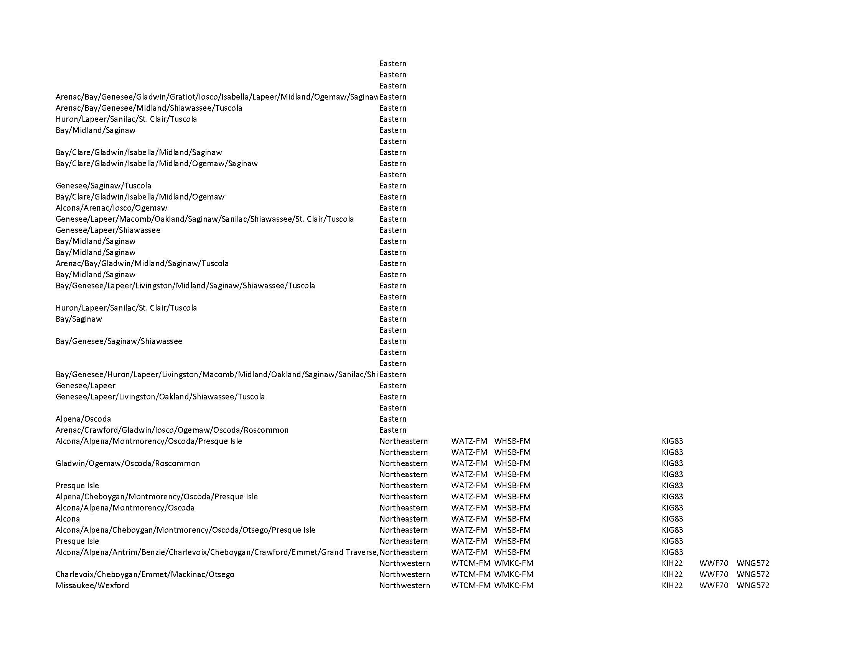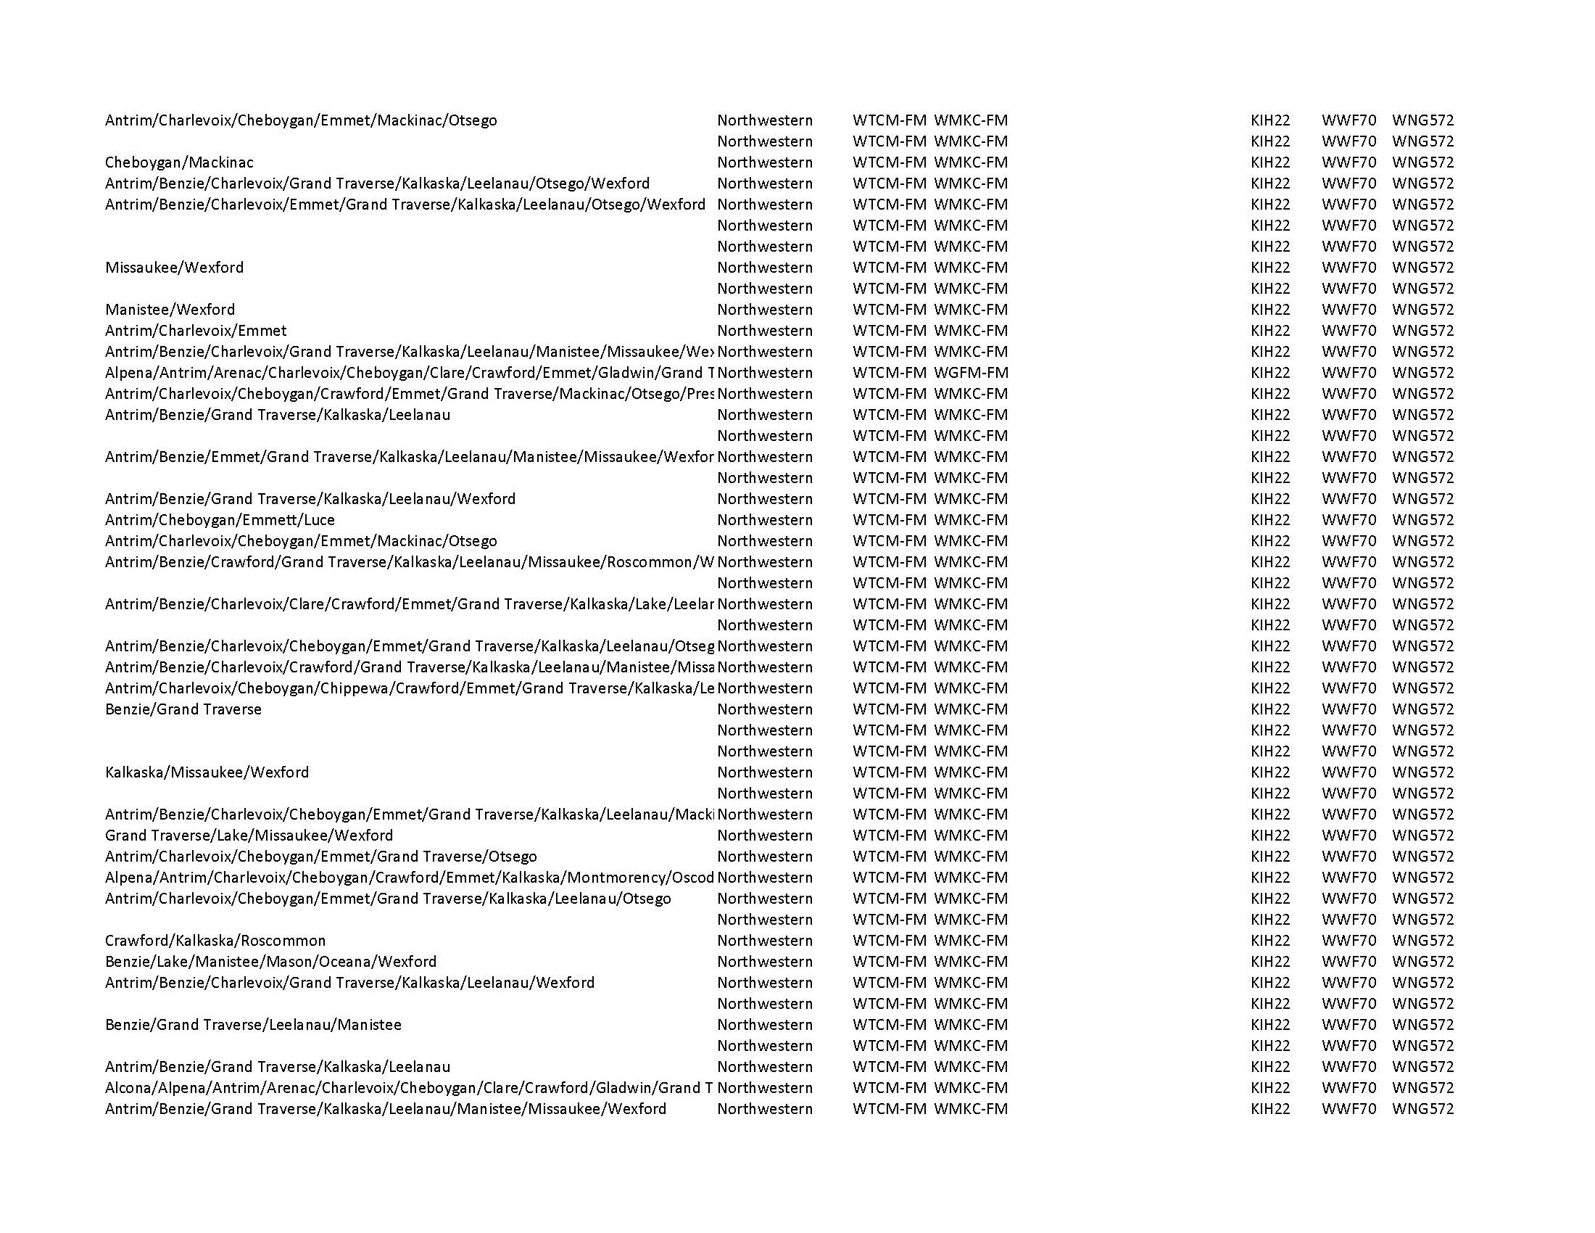

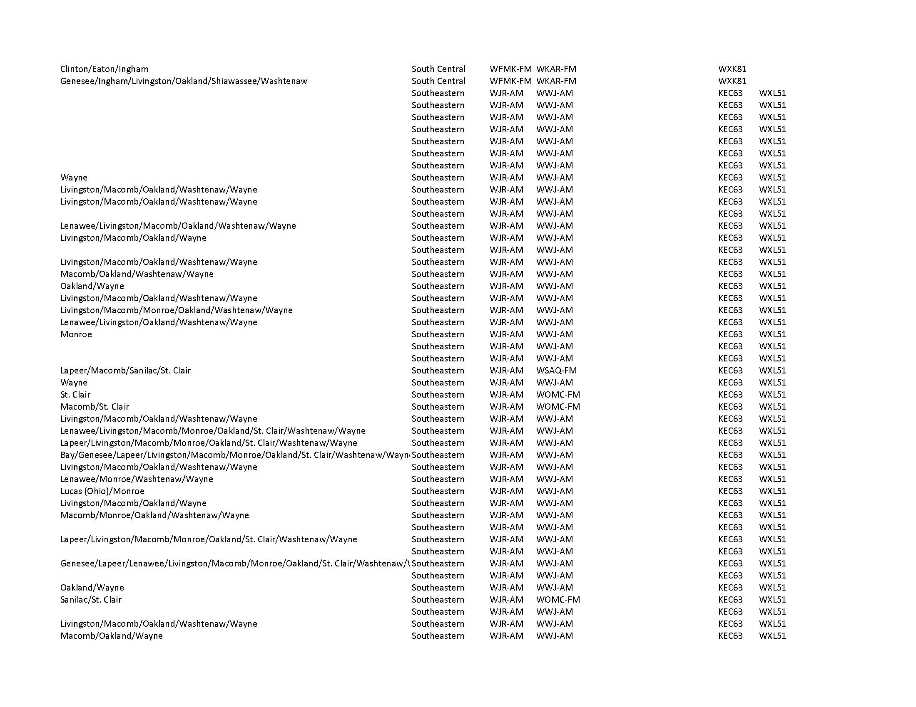

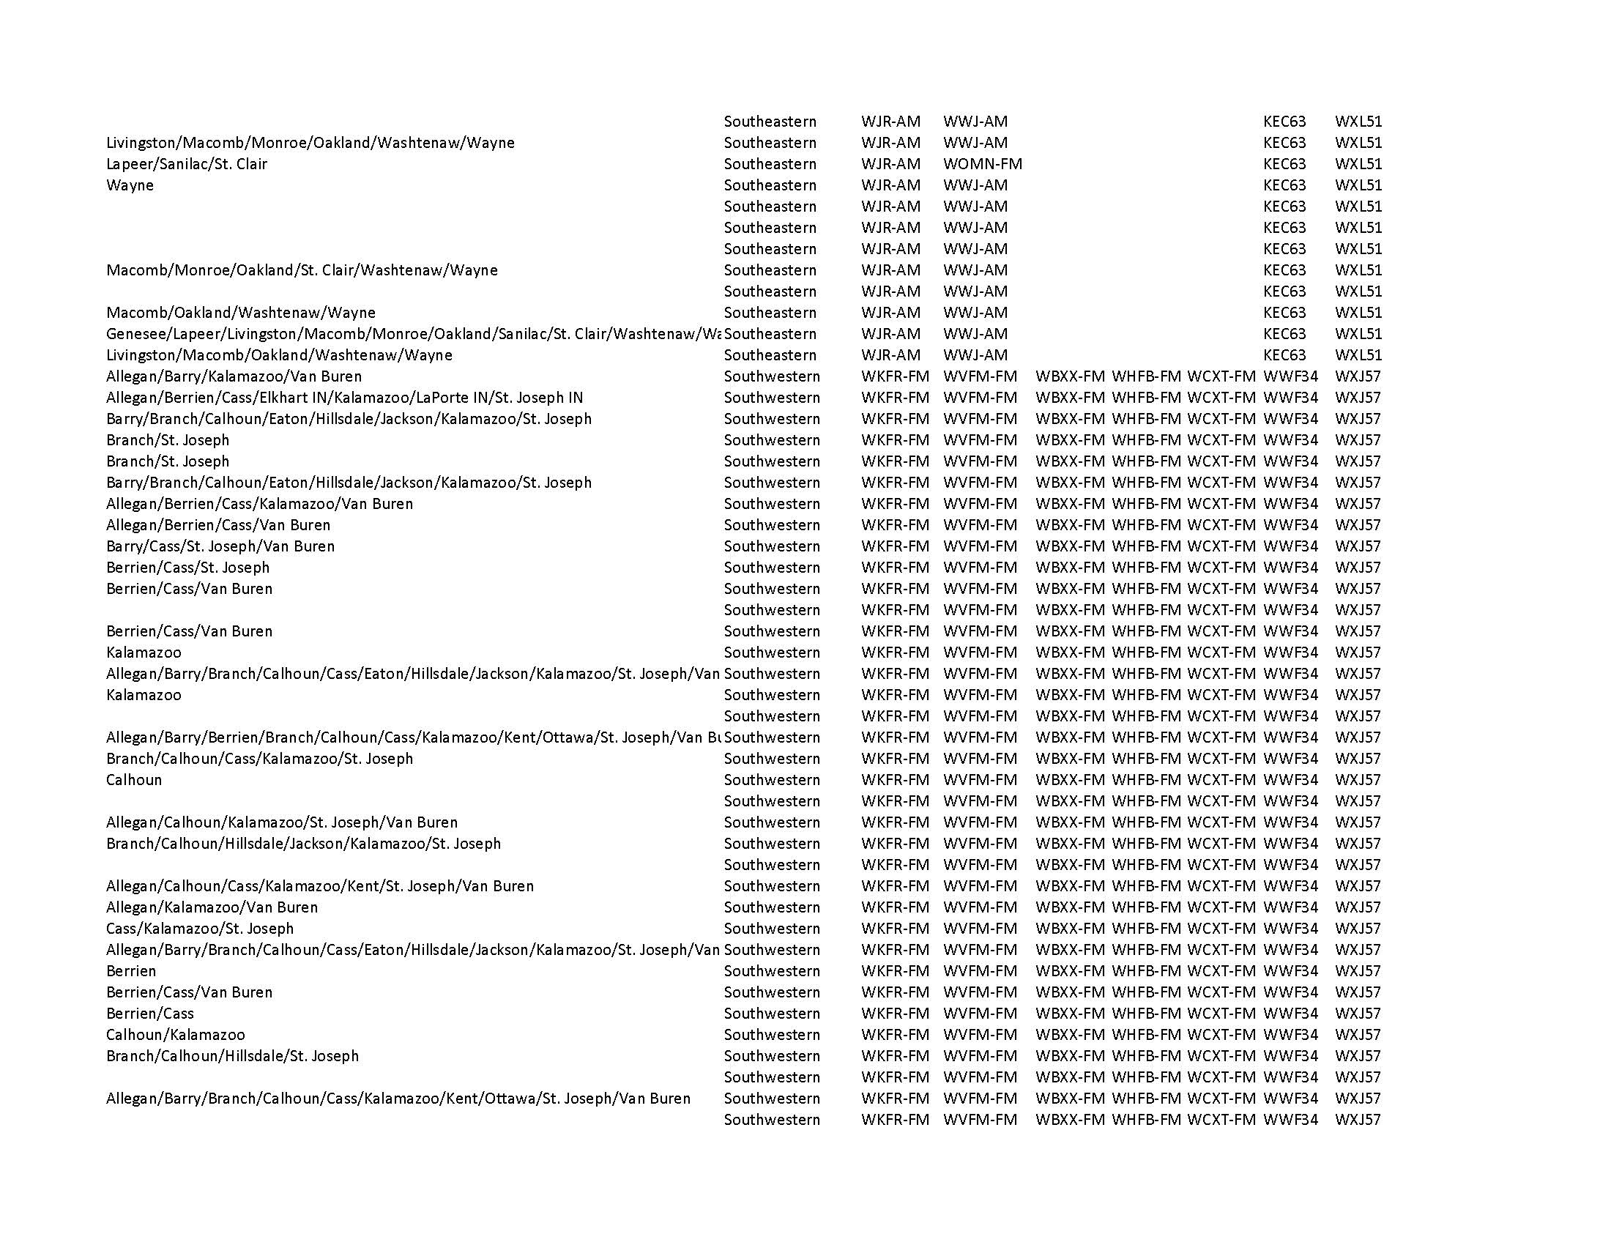

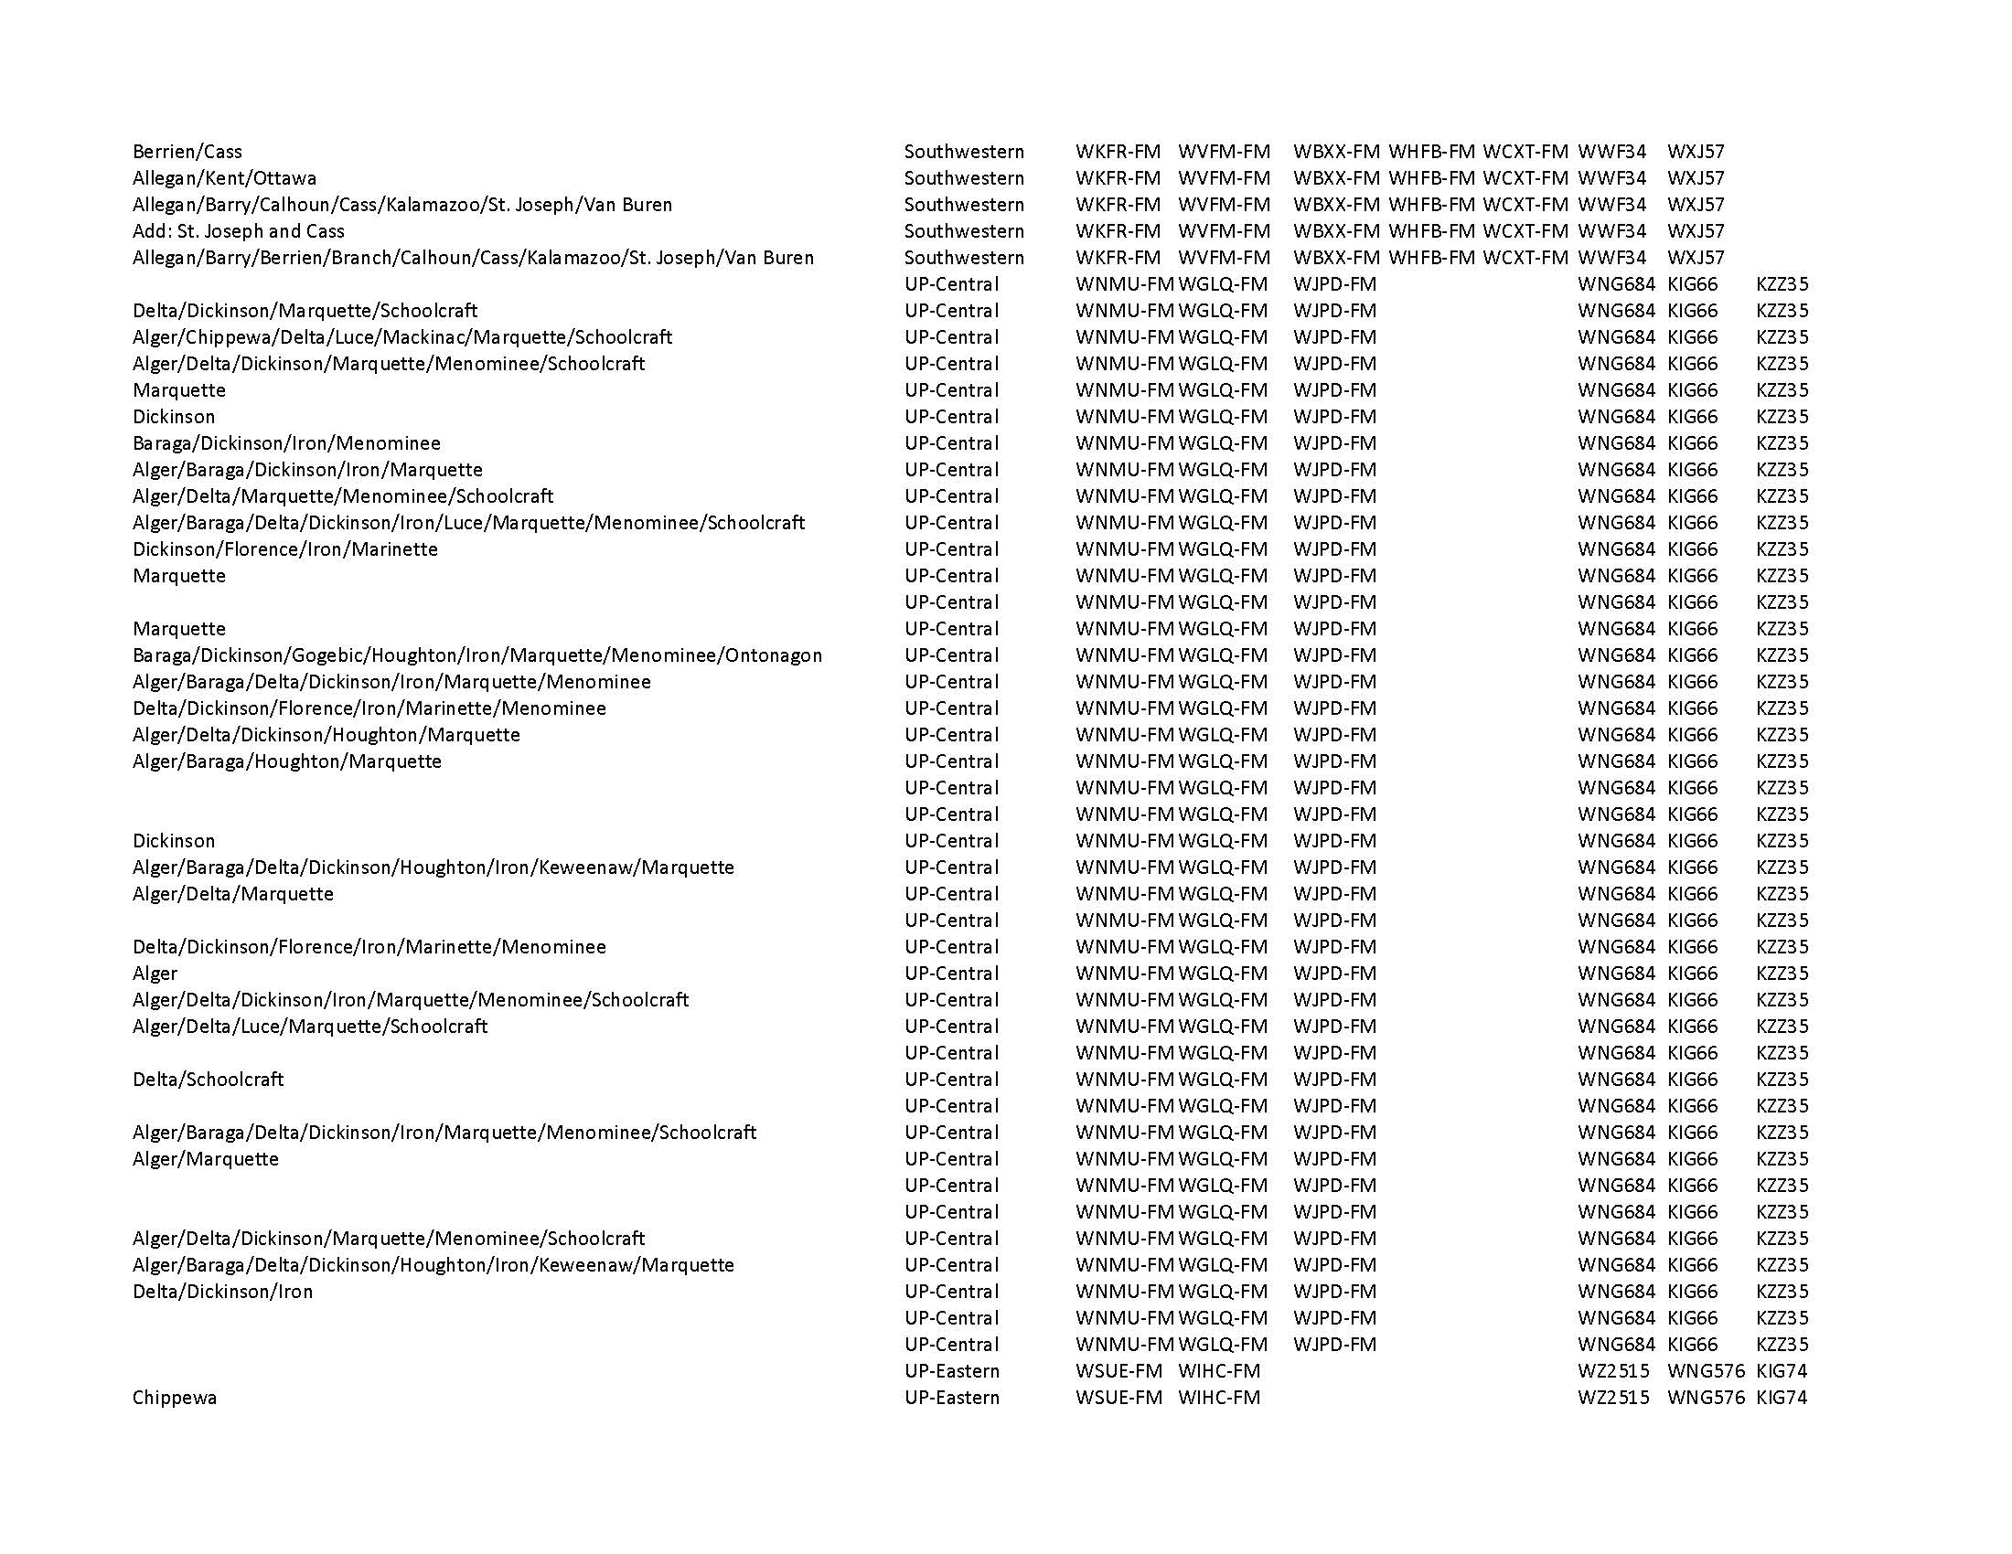

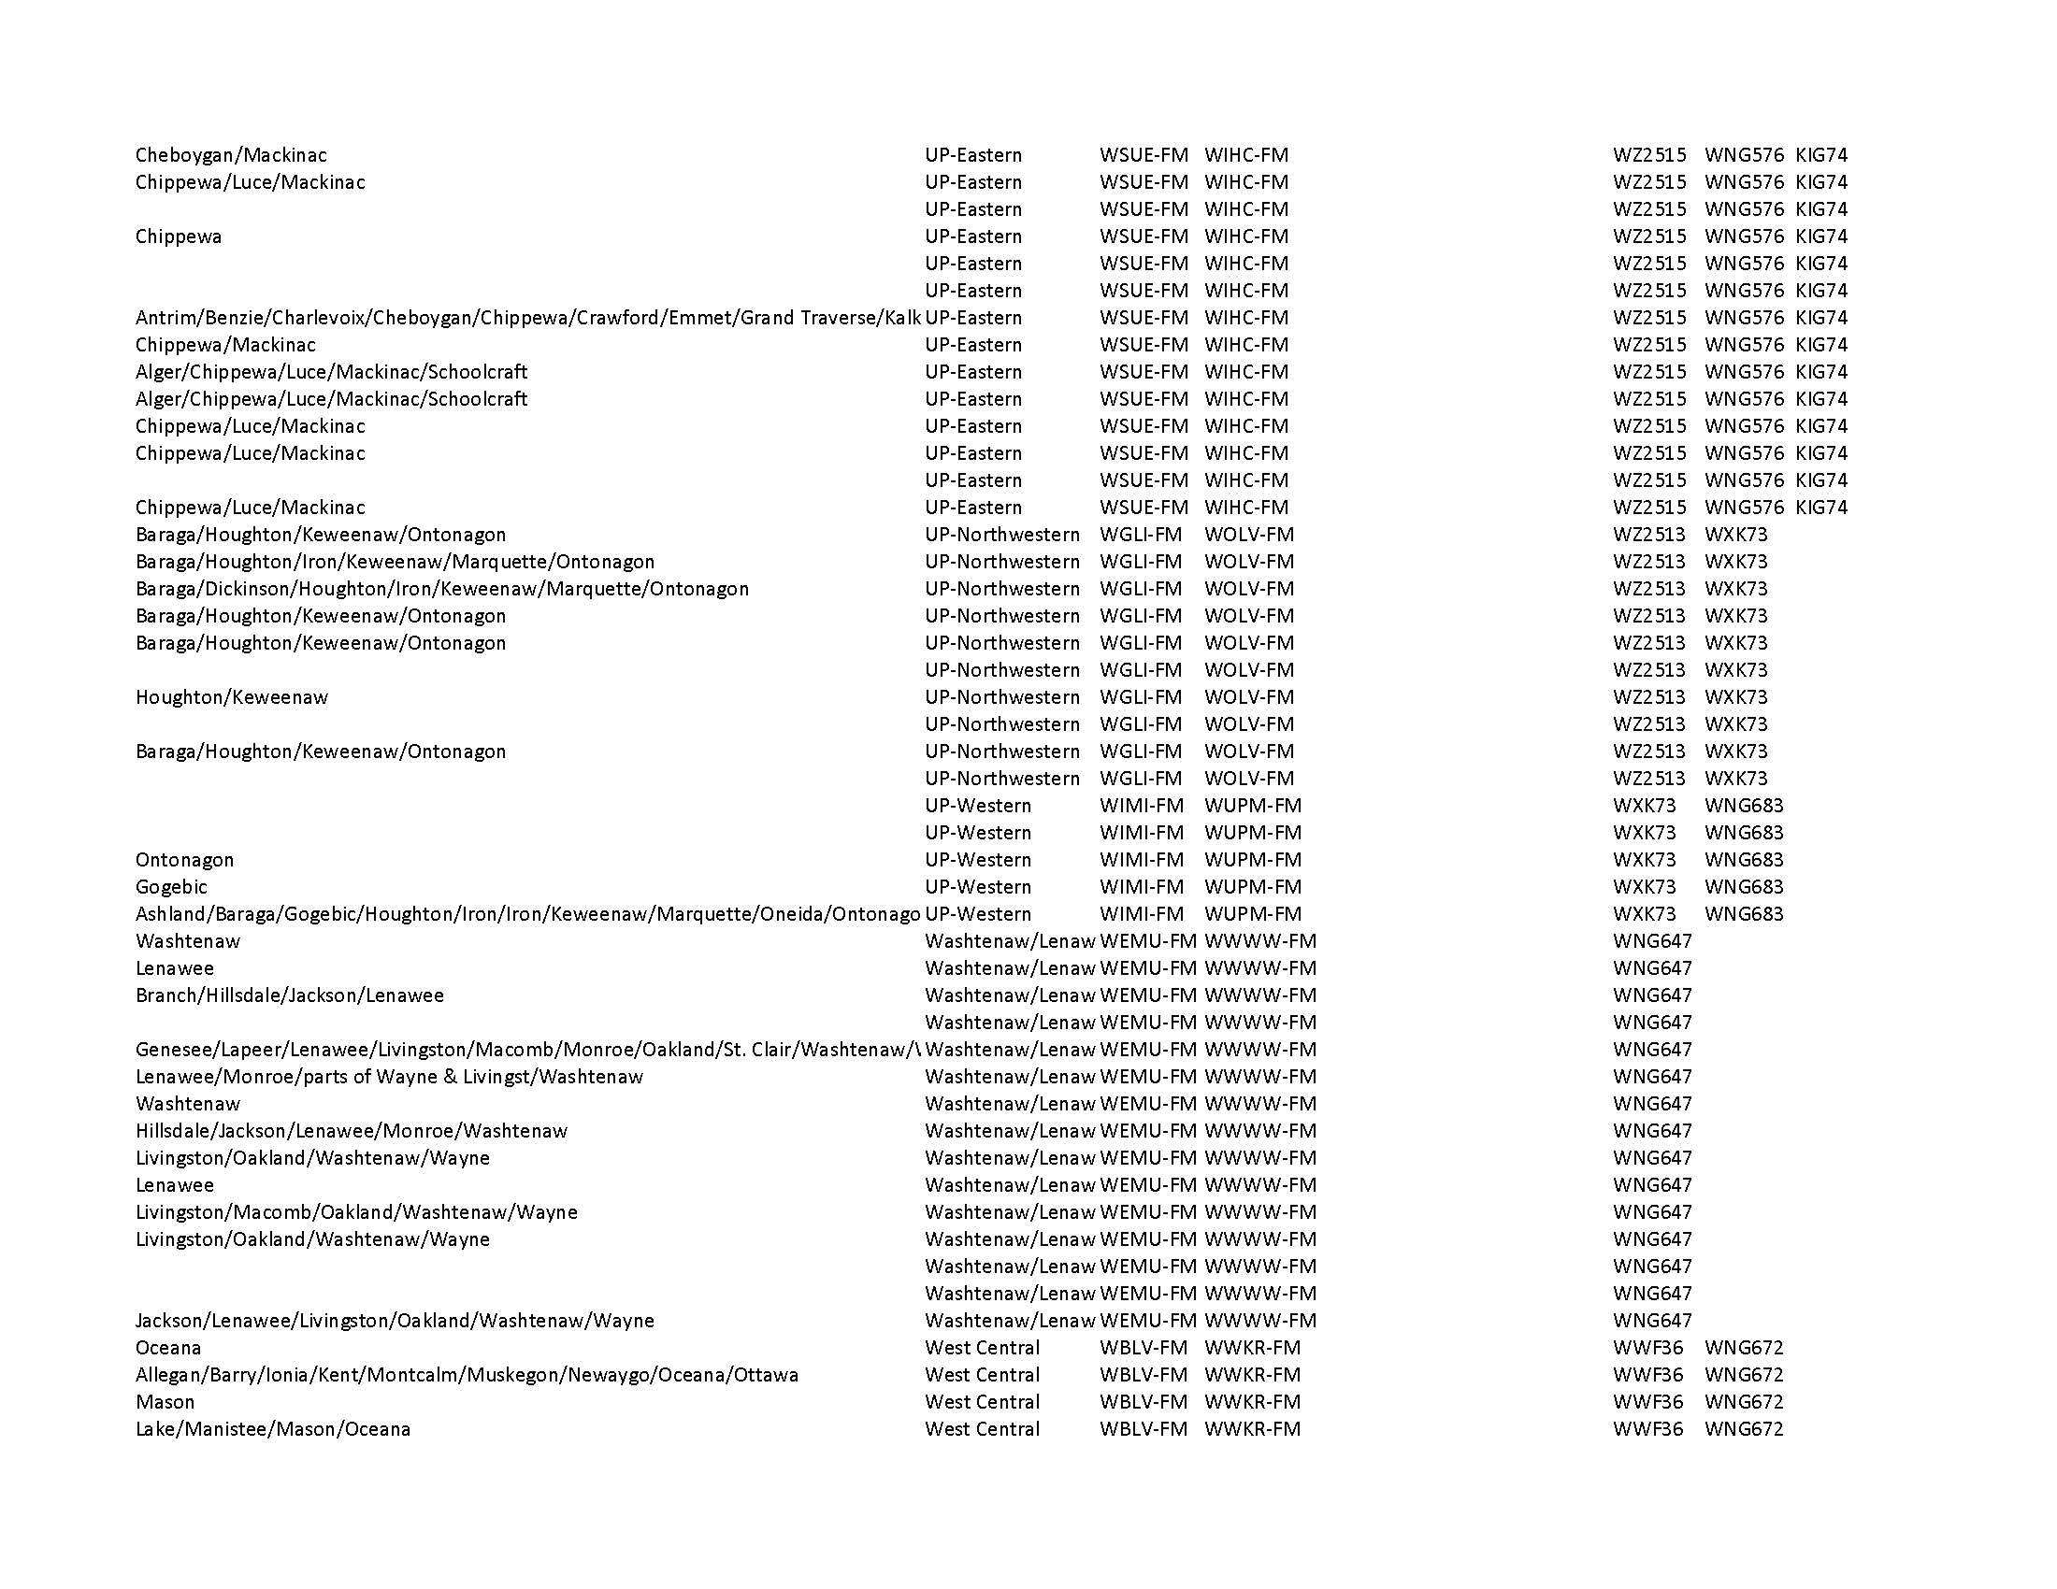

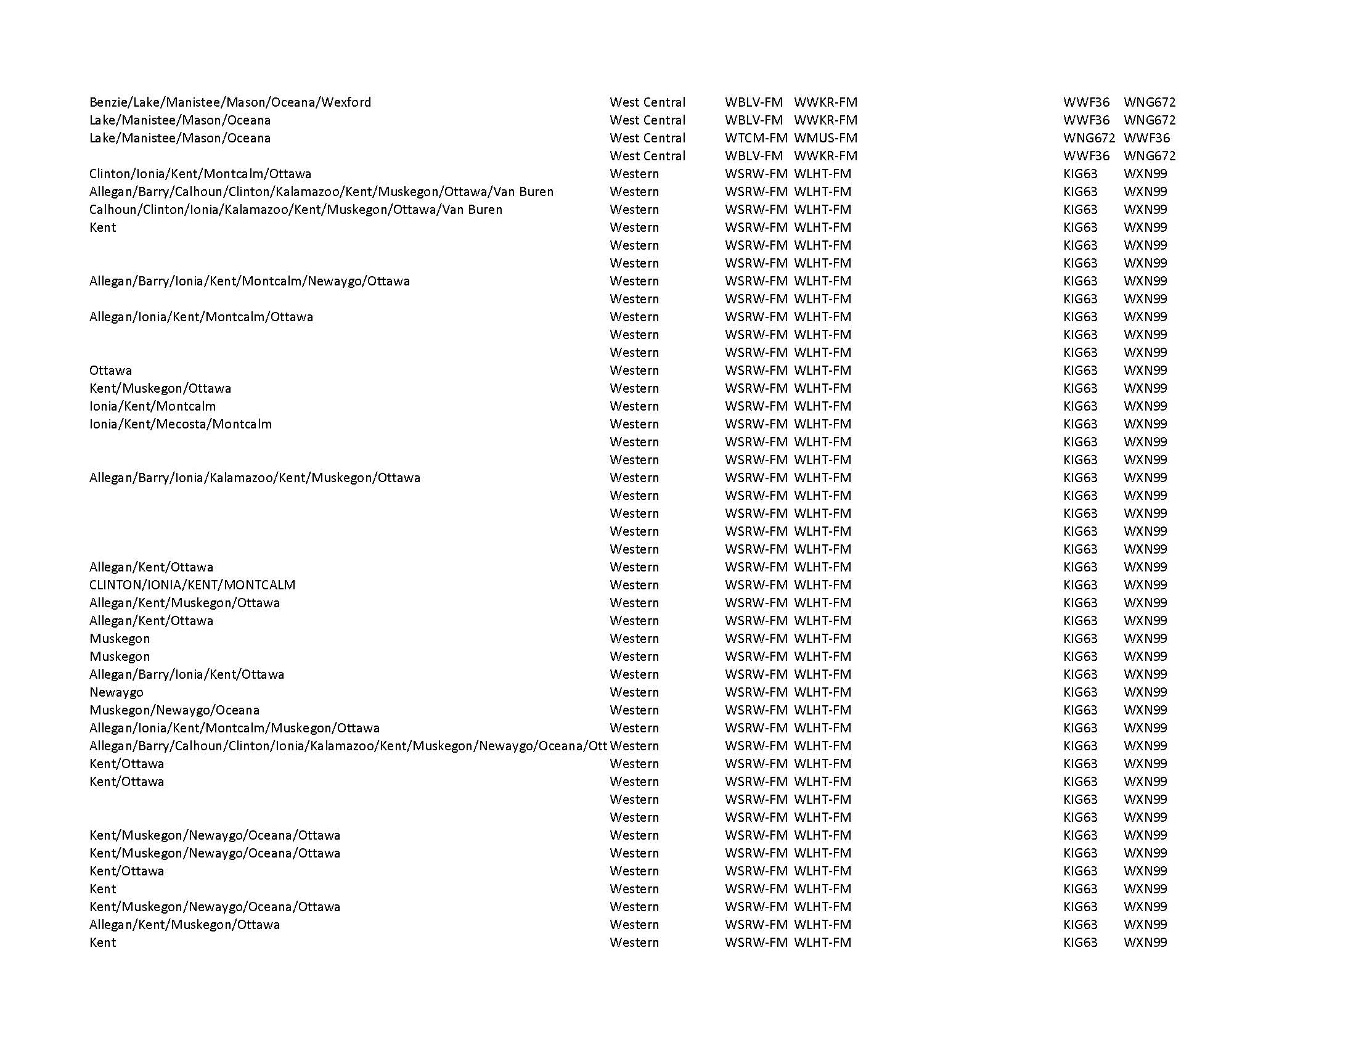

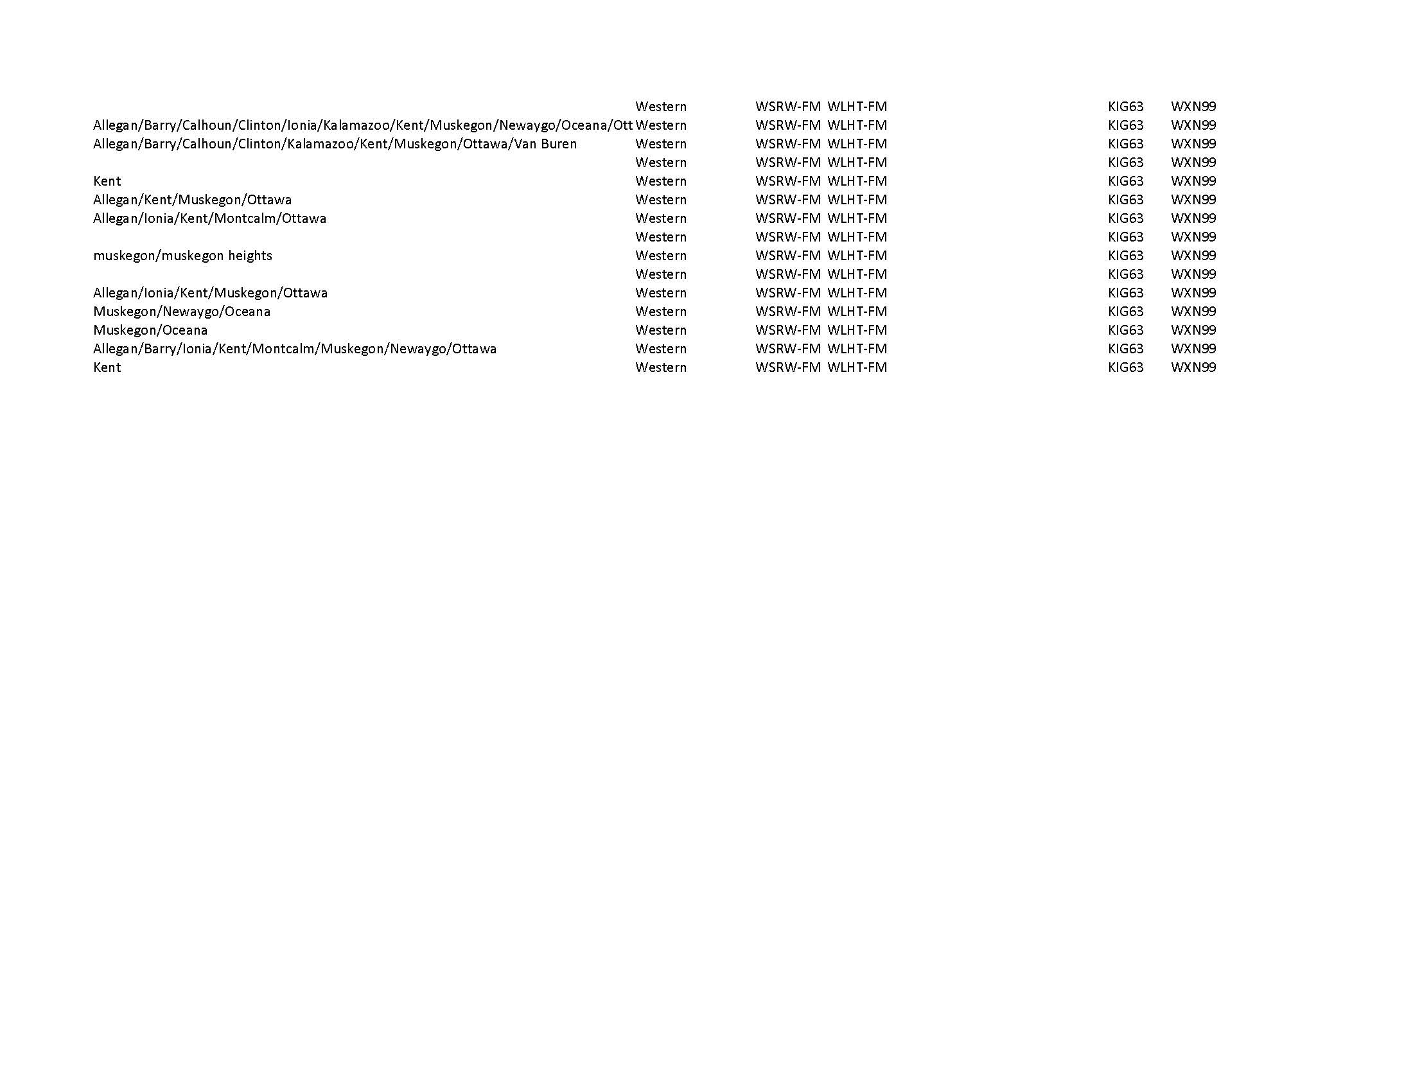

Appendix E: Authentication Procedures

Appendix E-1: State Police

The State of Michigan uses EMnet to authenticate all communications that occur on the system. Additional authentication procedures used for State level activation of the EAS are determined by the Michigan State Police Emergency Management and Homeland Security Division and the SECC.

The MSP MIOC will create and disseminate all State alerts (and local as needed) via their EMnet terminal to all EAS local primary stations and all broadcast and cable systems. The State Emergency Operations Center (SEOC) is equipped with CAP compliant EAS encoding equipment including EMnet, as well as a conventional EAS encoder/decoder connected by a dedicated telephone pair backed up by VHF and 800 MHz radios.

As in all users, necessary COG authorizations for users will be obtained.

Appendix E-2: National Oceanic and Atmospheric Administration (NOAA)

National Weather Service (NWS) warnings received via NOAA Weather Radio, NOAA Wire, and NOAA Integrated Public Alert and Warning System, AP, Reuters and other wire services do not need additional authentication.

Appendix E-3: County

Warning messages from all Michigan County Emergency Managers first require secure access verification (see COG procedures, Appendix L).

Appendix E-4: Local

Local authorities such as those at some larger cities, educational institutions, and nuclear power plants should direct activation requests to the appropriate County Emergency Management officials.

Appendix F: Scripts

Appendix F-1: Required Monthly Test – Local/State Origination Script

Anyone originating this test should use the RMT script as prescribed in their respective EAS area plan or use the following script which will be used in State EAS RMTs. All other broadcasters and cable operators will receive the test in this format and must re-transmit it within 60 minutes in the same format.

Stop regular programming

Optional station intro

“This is a test of the Emergency Alert System."

One-second pause

Send EAS Header Code three (3) times. [All sources must use Event Code "RMT" for this test]

Send EAS Attention Signal (8 seconds)

Read Test Script

This is a test of THE (name of EAS area) EMERGENCY ALERT SYSTEM originating from an EAS Local Primary Station

or
(_________________ County Emergency Operations Center)

or

(The State Emergency Operations Center in Lansing)

"If this had been an actual emergency, such as a tornado, a toxic material release, nuclear plant incident or other state or local emergency that affects your safety, official messages would have followed the ALERT tone.

THIS CONCLUDES THIS TEST OF THE EMERGENCY ALERT SYSTEM"

One-second pause

Send EAS End-of-Message Code (unit will repeat EOM 3 times)

One-second pause

Optional station close:

"This station (or call letters) serves the ___________________ area."
(name of EAS area)

Resume normal programming

Timing Note: The preceding script can be read in 22 seconds. All other elements of the Required Monthly Test including the Header Codes with an 8-second Attention Signal and EOM codes take from 22 to 30 seconds to complete with the length depending on the number of county codes contained in the Header. This script is to fit the RMT into a 60-second time period. State Relay and Local Primary stations and emergency agencies should make sure to complete this test in less than 60 seconds. Pre-recording the script at the length needed to achieve this goal is recommended.

Appendix F-2: Local Activation Procedure

The following is a suggested Local Area Activation Format for manually forwarding a local activation.

Stop regular programming

Optional Intro:

“We interrupt our programming to activate the (Local Area) Emergency Alert System.

Important information will follow.” (0:05)

One-second pause

Forward the stored Local Event Code, which will send the EAS attention signal, the recorded message and the EOM (End of Message)

Emergency Message as recorded voice of the Emergency Official

Note: The emergency message may be the recorded voice of the Emergency Official, or a computer generated text to speech message. It should never contain the station's call letters or frequency, since it will be re-broadcast by other stations. It must not be longer than 118 seconds.

One-second pause

Resume normal programming

Appendix F-3: State Activation

The format for a state EAS activation is as follows:

Forward the incoming EAS message with Event Code: “CEM”
(Unit will repeat the header 3 times)

(Unit will send EAS Attention Signal – 8 seconds)

Unit will Send ACTIVATION SCRIPT:

"We interrupt our regular programming to activate the Michigan Emergency Alert System. Here is a message from the Governor of the State of Michigan.

Governor's Message: (Must not exceed 118 seconds or it will be cut off by EAS decoders)

Following the Governor's message, the EAS EOM will be sent.

Resume normal programming

Appendix G: List of Federal Information Processing Standards (FIPS) Codes

EAS Areas | Location | FIPS Code
All of United States | All States | 000000
All of Michigan | Michigan | 26000
Northeastern | Alcona | 26001
UP-Central | Alger | 26003
Southwestern | Allegan | 26005
Northeastern | Alpena | 26007
Northwestern | Antrim | 26009
Eastern | Arenac | 26011
UP-Northwestern | Baraga | 26013
Southwestern | Barry | 26015
Eastern | Bay | 26017
Northwestern | Benzie | 26019
Southwestern | Berrien | 26021
Southwestern | Branch | 26023
Southwestern | Calhoun | 25025
Southwestern | Cass | 26027
Northwestern | Charlevoix | 26029
Northwestern | Cheboygan | 26031
UP-Eastern | Chippewa | 26033
Central | Clare | 26035
South Central | Clinton | 26037
Northwestern | Crawford | 26039
UP-Central | Delta | 26041
UP-Central | Dickinson | 26043
South Central | Eaton | 26045
Northwestern | Emmet | 26047
Eastern | Genesee | 26049
Eastern | Gladwin | 26051
UP-Western | Gogebic | 26053
Northwestern | Grand Traverse | 26055
Central | Gratiot | 26057
South Central | Hillsdale | 26059
UP-Northwestern | Houghton | 26061
Eastern | Huron | 26063
South Central | Ingham | 26065
Western | Ionia | 26067
Eastern | Iosco | 26069
UP-Central | Iron | 26071
Central | Isabella | 26073
South Central | Jackson | 26075
Southwestern | Kalamazoo | 26077
Northwestern | Kalkaska | 26077
Western | Kent | 26081
UP-Northwestern | Keweenaw | 26083
West Central | Lake | 26085
Eastern | Lapeer | 26087
Northwestern | Leelanau | 26089
Washtenaw/Lenawee | Lenawee | 26091
South Central | Livingston | 26093
UP-Eastern | Luce | 26095
UP-Eastern | Mackinac | 26097
Southeastern | Macomb | 26099
Northwestern | Manistee | 26101
UP-Central | Marquette | 26103
West Central | Mason | 26105
Central | Mecosta | 26107
UP-Central | Menominee | 26109
Eastern | Midland | 26111
Northwestern | Missaukee | 26113
Southeastern | Monroe | 26115
Western | Montcalm | 26117
Northeastern | Montmorency | 26119
Western | Muskegon | 26121
Western | Newaygo | 26123
Southeastern | Oakland | 26125
West Central | Oceana | 26127
Eastern | Ogemaw | 26129
UP-Western | Ontonagon | 26131
Central | Osceola | 26133
Northeastern | Oscoda | 26135
Western | Ottawa | 26139
Northeastern | Presque Isle | 26141
Central | Roscommon | 26143
Eastern | Saginaw | 26145
Eastern | Sanilac | 26151
UP-Central | Schoolcraft | 26153
South Central | Shiawassee | 26155
Southeastern | St. Claire | 26147
Southwestern | St. Joseph | 26149
Eastern | Tuscola | 26157
Southwestern | Van Buren | 26159
Washtenaw/Lenawee | Washtenaw | 26161
Southeastern | Wayne | 26161
Northwestern | Wexford | 26165

Appendix H: List of Federal Event Codes

FCC Code | Event
ADR | Administrative Message
AVA | Avalanche Warning
AVW | Avalanche Warning
BZW | Blizzard Warning
CAE | Child Abduction Emergency
CDW | Civil Danger Warning
CEM | Civil Emergency Message
CFA | Coastal Flood Watch
CFW | Coastal Flood Warning
DMO | Practice/Demo
DSW | Dust Storm Warning
EAN* | Emergency Action Notification*
EQW | Earthquake Warning
EVI | Evacuation Warning
FFA | Flash Flood Watch
FFS | Flash Flood Statement
FFW | Flash Flood Warning
FLA | Flood Watch
FLS | Flood Statement
FLW | Flood Warning
FRW | Fire Warning
HLS | Hurricane Statement
HMW | Hazardous Materials Warning
HUA | Hurricane Watch
HUW | Hurricane Warning
HWA | High Wind Watch
HWW | High Wind Watch
LAE | Local Area Emergency
LEW | Law Enforcement Warning
NIC | National Information Center (National)
NMN | Network Message Notification
NPT | National Periodic Test
NUW | Nuclear Power Plant Warning
RHW | Radiological Hazard Warning
RMT* | Required Monthly Test*
RWT* | Required Weekly Test*
SMW | Special Marine Warning
SPS | Special Weather Statement
SVA | Severe Thunderstorm Watch
SVR | Severe Thunderstorm Warning
SVS | Severe Weather Statement
TOA | Tornado Watch
TOE | 911 Telephone Outage Emergency
TOR | Tornado Warning
TRA | Tropical Storm Watch
TRW | Tropical Storm Warning
TSW | Tsunami Warning
TWA | Tsunami Watch
VOW | Volcano Warning
WSA | Winter Storm Watch
WSW | Winter Storm Warning

*Minimum required codes

Appendix I: Michigan FIPS Codes

Area | County Name | County FIPS Code
Central | Clare | 26035
Central | Gratiot | 26057
Central | Isabella | 26073
Central | Mecosta | 26107
Central | Osceola | 26133
Central | Roscommon | 26143
Eastern | Arenac | 26011
Eastern | Bay | 26017
Eastern | Genesee | 26049
Eastern | Gladwin | 26051
Eastern | Huron | 26063
Eastern | Iosco | 26069
Eastern | Lapeer | 26087
Eastern | Midland | 26111
Eastern | Ogemaw | 26129
Eastern | Saginaw | 26145
Eastern | Sanilac | 26151
Eastern | Tuscola | 26157
Northeastern | Alcona | 26001
Northeastern | Alpena | 26007
Northeastern | Montmorency | 26119
Northeastern | Oscoda | 26135
Northeastern | Presque Isle | 26141
Northwestern | Antrim | 26009
Northwestern | Benzie | 26019
Northwestern | Charlevoix | 26029
Northwestern | Cheboygan | 26031
Northwestern | Crawford | 26039
Northwestern | Emmet | 26047
Northwestern | Grand Traverse | 26055
Northwestern | Kalkaska | 26077
Northwestern | Leelanau | 26089
Northwestern | Manistee | 26101
Northwestern | Missaukee | 26113
Northwestern | Wexford | 26165
South Central | Clinton | 26037
South Central | Eaton | 26045
South Central | Hillsdale | 26059
South Central | Ingham | 26065
South Central | Jackson | 26075
South Central | Livingston | 26093
South Central | Shiawassee | 26155
Southeastern | Macomb | 26099
Southeastern | Monroe | 26115
Southeastern | Oakland | 26125
Southeastern | St. Claire | 26147
Southeastern | Wayne | 26161
Southwestern | Allegan | 26005
Southwestern | Barry | 26015
Southwestern | Berrien | 26021
Southwestern | Branch | 26023
Southwestern | Calhoun | 25025
Southwestern | Cass | 26027
Southwestern | Kalamazoo | 26077
Southwestern | St. Joseph | 26149
Southwestern | Van Buren | 26159
UP-Central | Alger | 26003
UP-Central | Delta | 26041
UP-Central | Dickinson | 26043
UP-Central | Iron | 26071
UP-Central | Marquette | 26103
UP-Central | Menominee | 26109
UP-Central | Schoolcraft | 26153
UP-Eastern | Chippewa | 26033
UP-Eastern | Luce | 26095
UP-Eastern | Mackinac | 26097
UP-Northwestern | Baraga | 26013
UP-Northwestern | Houghton | 26061
UP-Northwestern | Keweenaw | 26083
UP-Western | Gogebic | 26053
UP-Western | Ontonagon | 26131
Washtenaw/ Lenawee | Lenawee | 26091
Washtenaw/ Lenawee | Washtenaw | 26161
West Central | Lake | 26085
West Central | Mason | 26105
West Central | Oceana | 26127
Western | Ionia | 26067
Western | Kent | 26081
Western | Montcalm | 26117
Western | Muskegon | 26121
Western | Newaygo | 26123
Western | Ottawa | 26139
West Central | Lake | 26085
West Central | Mason | 26105
West Central | Oceana | 26127

Appendix J: Standard Operational Tests. This section is in development and will be amended at a future date.

Appendix K: EAS Message Protocol Overview
The EAS system uses a four-part message structure for emergency activation. The four parts are:
- The preamble and EAS header codes
- The audio attention signal
- The EAS message audio text
- The end-of-message code

Appendix K-1: Message Protocol Explanation

The protocol that follows is provided for information only. The actual generation of EAS messages using FCC approved equipment will be more user-friendly. The equipment will allow generation of the message codes using plain English entries through menu prompts.

1. The Preamble and EAS Header
The preamble and EAS header code contains specific information related to the origination, handling, and routing of the EAS message. The code is transmitted by an EAS encoder three times with a one-second pause between transmissions. The code format is as follows:

(Preamble) ZCZC-ORG-EEE-PSSCCC+TTTT-JJJHHMM-LLLLLLLL

The preamble portion of this code contains a consecutive string of data bits used to clear the system equipment, set the equipment automatic gain control, and set the decoder clocking cycles. This is a fixed code that is used at the beginning of all EAS headers and end of all message codes.

ZCZC = (start of ASCII code) Sent automatically by the EAS Encoder.

ORG = (the originator code) Pre-set once by user then sent automatically by the encoder.

The following originator codes are used as part of the Michigan EAS.

Table 1: EAS Originator Codes

Originator | Code
Broadcast Station or Cable System | EAS
Civil Authority | CIV
National Weather Service (NWS) | WXR

The following codes are used for National originators and are installed by the equipment manufacturer:

Table 2: National EAS Origination Codes

Alert | Code
Emergency Action Notification | EAN (National Use ONLY)
National Periodic Test | NPT (National Use ONLY)
EEE = (the event code) Determined by the user each time an alert is sent and indicates the nature of the EAS activation.

See Appendix I for the list of event codes to be used in the Michigan EAS. Event codes marked ** are required to be programmed as pre-sets in all EAS decoders by FCC rules. Event codes marked * are specified to be programmed as pre-sets in all EAS decoders of stations and cable systems participating in the Michigan EAS System.

PSSCCC = (the location code) Determined by the user each time an alert is sent. This code indicates the geographic area affected by the EAS alert. Up to 31 location codes can be put into one EAS alert header. The location code uses the Federal Information Processing System (FIPS) numbers to define areas. The PSSCCC code breakout is as follows:

The “P” defines county subdivisions as indicated in the following table.
A “0” in the “P” position indicates an entire county.

Table 3: County-Level EAS Location Codes

Numeric Indicator | County Subdivision
0 | No Indication
1 | North West
2 | North Central
3 | North East
4 | West Central
5 | Central
6 | East Central
7 | South West
8 | South Central
9 | South East
Michigan does not anticipate using county subdivisions at the present time. Therefore, a “0” should be used as “P” code.

TTTT-JJJHHMM = (the identifier code) Chosen identity for the originating broadcast station. This is chosen by the broadcaster. This portion of the code allows flexibility for the broadcaster. The following examples will lend guidance to parties attempting to determine the identifier portion of the code:

Table 4: Examples of EAS Identification Codes with Explanations

Example | Explanation
WGRYAMFM | Broadcast Station Combination (AM/FM)
WILSWHZZ | Broadcast Station Combination (with different call letters)
WFMK-FM | Single Broadcast Station
WHMI-FM | Single Broadcast Station
WDIV-TV | Television Station
WILX-TV | Television Station
KDTX/NWS | NWS, NOAA Weather Radio
WAYNEEM | County Emergency Management (ex: Wayne County)
MARQCEOC | County EOC (ex: Marquette County)
MSPSEOC | State Emergency Operations Center
LLLLLLLL = (portion of the code for county emergency manager encoders)

2. Audio Attention Signal
The audio attention signal is a two-tone signal transmitted after the EAS header code. This signal is eight (8) seconds in duration and alerts listeners to an upcoming emergency broadcast.

3. EAS Message Text
The EAS message text is the emergency message to be transmitted. All South Central Michigan Region EAS messages should begin with the statement:

“WE INTERRUPT THIS PROGRAM TO ACTIVATE THE SOUTH CENTRAL MICHIGAN AREA EMERGENCY ALERT SYSTEM FOR SPECIAL EMERGENCY INFORMATION”

All South Central Michigan Region EAS messages will end with the statement:

“THIS CONCLUDES THIS MESSAGE REGARDING THE ACTIVATION OF THE SOUTH CENTRAL MICHIGAN AREA EMERGENCY ALERT SYSTEM. STAY TUNED TO THIS STATION FOR FURTHER INFORMATION.”

This audio message, including open, close and body must be limited to two (2) minutes to fit within the recording space provided in the EAS Decoders.

4. End-of-Message Code
The end-of-message code is generated by pushing a button and is the preamble followed by a string of four ASCII “N” characters. The end-of-message code is transmitted by the encoder three times with one-second pauses between transmissions. The purpose is to return automated broadcast programming equipment to normal programming after an EAS interruption.

5. Jurisdiction

The EAS Protocol described above is taken from the FCC Rules Part 11 and shall be used exclusively by the Michigan EAS System. Each participating station, cable system and emergency manager in the State shall program their EAS equipment to facilitate the proper functioning of the system as described in this plan.

Appendix L: Michigan Collaborating Operating Group (COG) Information

Please see the FEMA web site for current IPAWS policies

Appendix M: State Police Districts - EAS Area Maps – NOAA NWS Radio Maps

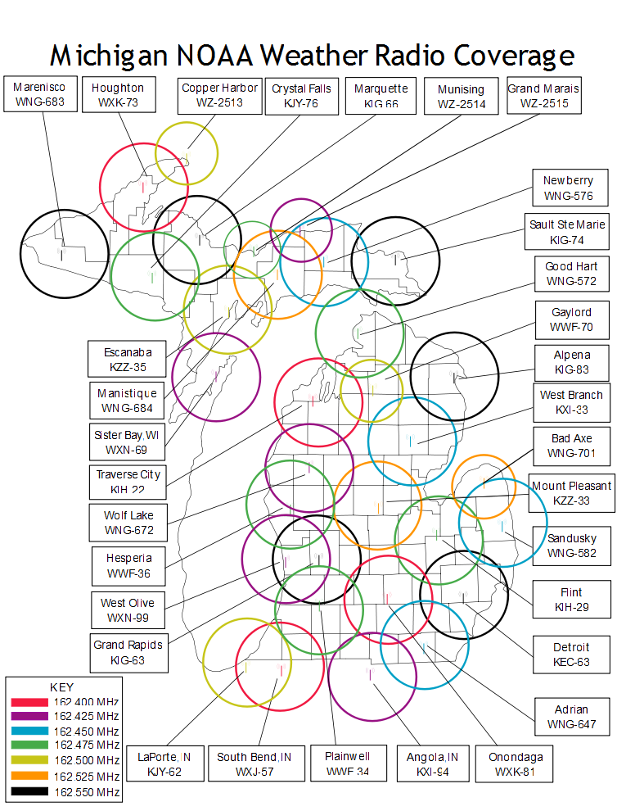

Appendix M-1: State Police

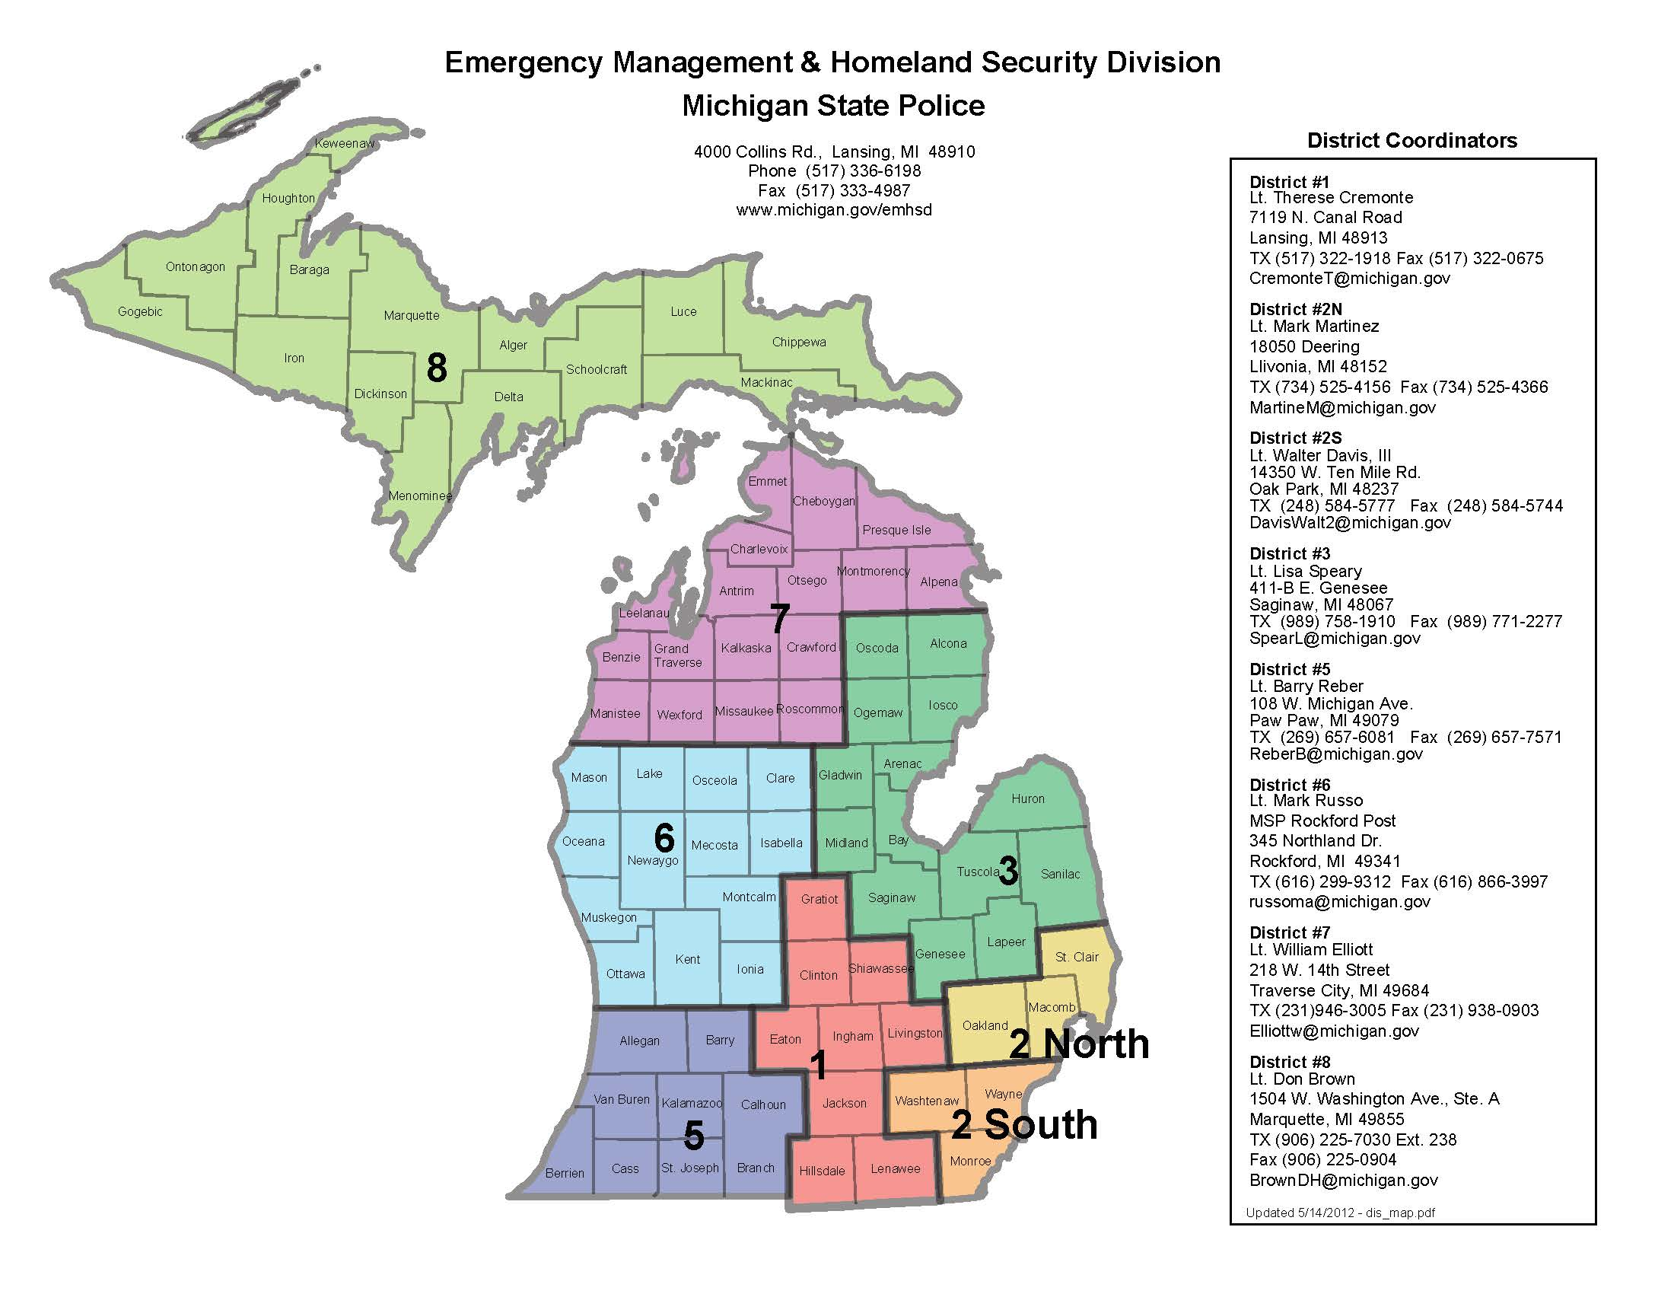

Appendix M-2: EAS Areas

Appendix N: List of EAS Local Areas

Appendix N-1: Southeastern

Macomb County
Monroe County
Oakland County
St. Clair County
Wayne County

Appendix N-2: Southwestern

Allegan County
Barry County
Berrien County
Branch County
Calhoun County
Cass County
Kalamazoo County
St. Joseph County
Van Buren County

Appendix N-3: South Central

Clinton County
Eaton County
Hillsdale County
Ingham County
Jackson County
Livingston County
Shiawassee County

Appendix N-4: Washtenaw-Lenawee

Lenawee County
Washtenaw County

Appendix N-5: Western

Ionia County
Kent County
Montcalm County
Muskegon County
Newaygo County
Ottawa County

Appendix N-6: West Central

Lake County
Mason County
Oceana County

Appendix N-7: Northwestern

Antrim County
Benzie County
Charlevoix County
Cheboygan County
Crawford County
Emmet County
Grand Traverse County
Kalkaska County
Leelanau County
Manistee County
Missaukee County
Otsego County
Roscommon County
Wexford County

Appendix N-8: Central

Clare County
Gratiot County
Isabella County
Mecosta County
Osceola County

Appendix N-9: East Central

Arenac County
Bay County
Gladwin County
Genesee County
Huron County
Iosco County
Lapeer County
Midland County
Ogemaw County
Saginaw County
Sanilac County
Tuscola County

Appendix N-10: Northeastern

Alcona County
Alpena County
Montmorency County
Oscoda County
Presque Isle County

Appendix N-11: Upper Peninsula – Eastern

Chippewa County
Luce County
Mackinac County

Appendix N-12: Upper Peninsula – Central

Alger County
Delta County
Dickinson County
Iron County
Marquette County
Menominee County
Schoolcraft County

Appendix N-13: Upper Peninsula – Western

Gogebic County
Ontonagon County

Appendix N-14: Upper Peninsula – Northwestern

Baraga County
Houghton County
Keweenaw County

Appendix O: Local EAS District Plans (Please refer to the local plans posted on this website.)

Appendix O-1: Southeastern

Appendix O-2: Southwestern

Appendix O-3: South Central

Appendix O-4: Washtenaw-Lenawee

Appendix O-5: Western

Appendix O-6: West Central

Appendix O-7: Northwestern

Appendix O-8: Central

Appendix O-9: East Central

Appendix O-10: Northeastern

Appendix O-11: Upper Peninsula – Eastern

Appendix O-12: Upper Peninsula – Central

Appendix O-13: Upper Peninsula – Western

Appendix O-14: Upper Peninsula - Northwestern

Appendix P: Record of Distribution

5/16/12 Local Emergency Communications Committee

5/16/12 State Emergency Communications Committee

Appendix Q: Record of Change

Date | Section | Description of Change
6/11/2013 | Appendix A,B,C,D | Updated Emergency Manager Contacts and LP 1 contact information.

Appendix R: Promulgation Page

